Data visualisation: An analysis of the asylum system – text version
This is a text version of the interactive visualisation found at https://nao-mesh.shinyapps.io/Asylum_Systems_Data_Visualisation/
If you require additional help accessing this information, you can contact us on +44(0)2077987264 or enquiries@nao.org.uk

Contents
Understanding the asylum system 2
Introduction 2
Map of the asylum system 3
Accompanying text for map of the asylum system 4
Figure detail from map of the asylum system 5
Demand and caseload in the asylum system - map 10
Accompanying text for demand and caseload in the asylum system 11
Figure detail for demand and caseload in asylum system - map 12
Demand and caseload in the asylum system – caseload chart 20
Caseload in 2020-21 20
Caseload in 2021-22 21
Caseload in 2022-23 21
Caseload in 2023-24 22
Caseload in 2024-25 23
Figure detail for demand and caseload in asylum system – caseload chart 23
Decisions and outcomes in the asylum system 23
Accompanying text for decisions and outcomes in the asylum system 24
Detail for decisions and outcomes in the asylum system 25
Journeys through the asylum system 32
Accompanying figure and text for journeys through the asylum system – Sankey 32
Accompanying figure and text for journeys through the asylum system – time figure 36
Accommodation and support in the asylum system 37
Accompanying text for accommodation and support in the asylum system 38
Figure detail for accommodation and support in the asylum system 39
Cost of the asylum system 46
Figure detail for cost of the asylum system 46
Accompanying text for cost of the asylum system 47
Key challenges to effectively managing the asylum system 48
A whole-system approach 49
Accompanying text for a whole-system approach 49
Figure detail for whole systems approach 50
Addressing fundamental barriers 53
Accompanying text for addressing fundamental barriers 53
Figure detail for addressing fundamental barriers 55
Timely, robust, shared data 56
Accompanying text for timely, robust, shared data 57
Figure detail for timely, robust, shared data 58
A resilient, strategic approach to capacity and workforce 59
Accompanying text for a resilient, strategic approach to capacity and workforce 59
Figure detail for a resilient, strategic approach to capacity and workforce 61
Study team 62

Understanding the asylum system

Introduction
Asylum is a form of protection available to anyone at risk of serious harm in their country of origin or residence, through conflict or persecution. As a signatory to the Refugee Convention and its 1967 Protocol Relating to the Status of Refugees, the UK is committed to not returning individuals to a country where they face persecution. The number of people seeking asylum represented around 11.4% of overall immigration to the UK in 2024 and around 0.16% as a share of total UK population in mid-2024.
Since the second half of 2021, there has been a notable increase in the number of people seeking asylum in the UK. While volumes of asylum claims represent a relatively small proportion of overall migration, the current cost of supporting people seeking asylum is disproportionately high (£4.0 billion in 2024-25), driven by long delays and backlogs. Delays also have wider negative consequences - for vulnerable people, for community cohesion, and for local authority housing. Delays make it harder for the government to deliver a system that is fair, well managed and resistant to abuse.
We have reported a number of times on aspects of the asylum system, with particular focus on asylum accommodation and support. We consider it is crucial that all parts of the end-to-end asylum system (including all relevant parts of the Home Office, Ministry of Justice and local authorities) work together to manage demand effectively and achieve value for money.
In December 2024, the government committed to restore order to the asylum and immigration system: clear the asylum backlog and end the use of asylum hotels; increase returns; and reduce small boat crossings. In 2025, it announced a number of further interventions, and in November 2025 set out a package of procedural and legal reforms it describes as "an entirely new asylum model". Many of these will need time and Parliamentary approval to introduce and together they represent a complex programme for system change.
To support Parliamentary and public scrutiny, we have developed a visual systems map of the asylum process. It shows which government bodies are involved, how claims progress through each stage, and how people are accommodated and supported while awaiting decisions. The visualisation provides a snapshot of the number of claims at key stages as at March 2025, recent processing trends and backlogs, and estimated overall costs. Finally, it presents our observations on key system enablers that the government needs to get right.
December 2025

Map of the asylum system
This map gives an overview of the asylum system as it currently works. Different colours in the map show different government departments and bodies working in the system. Rectangular nodes represent a process within the asylum system, while circular or oval nodes represent an outcome or state. The nodes in the separate box titled 'Accommodation and support' refer to different types of support available within the asylum system. Solid arrows represent a process, while dashed arrows represent a relationship between nodes in the asylum system. Start at the 'intake' node at the left of the map.
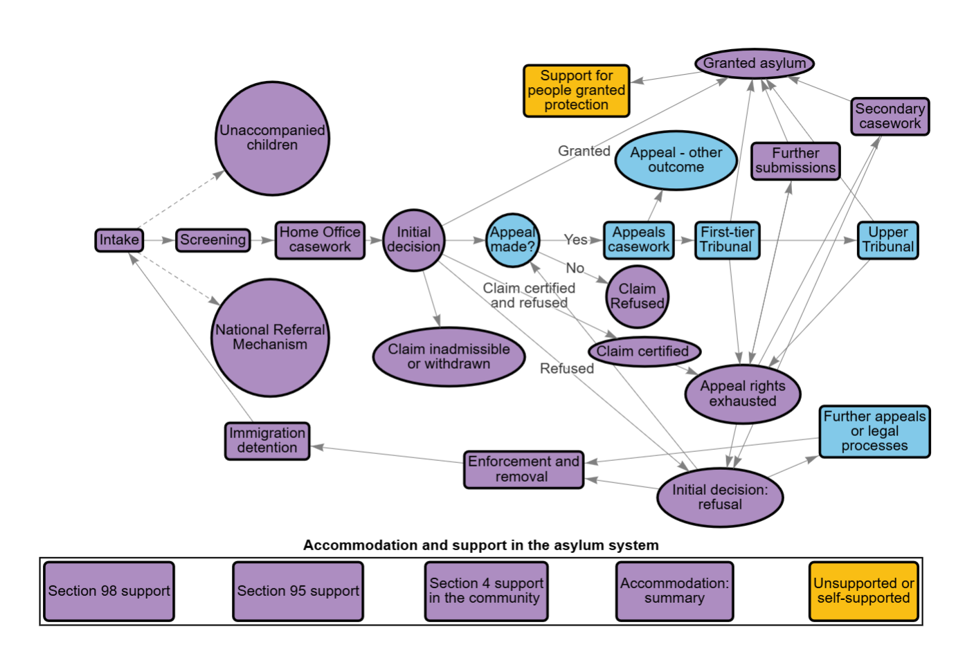

Accompanying text for map of the asylum system

Overall view of the system
The Home Office, Ministry of Justice (MoJ), HM Courts & Tribunals Service (HMCTS) and local authorities all have responsibility in the wider asylum system.

Home Office
The Home Office is responsible for ensuring the UK complies with its legal commitments to people seeking asylum. It manages the intake of people seeking asylum, makes decisions on claims, and manages the enforcement of the immigration rules, including removing people who have no right to remain in the UK. The Home Office has a statutory duty to accommodate and support people seeking asylum who would otherwise be destitute while their claim is being considered. The Home Office also funds the support and accommodation of unaccompanied asylum-seeking children.

Ministry of Justice
The Ministry of Justice (MoJ) and HM Courts & Tribunals Service (HMCTS) administer appeals and tribunals, working with the independent judiciary. The MoJ is also responsible for the provision of legal aid, which is administered by the Legal Aid Agency (LAA).

Local authorities
People seeking asylum are dispersed into local authority areas, into accommodation funded by the Home Office and provided by private suppliers, who procure and manage accommodation on the Home Office's behalf.
Local authorities provide support services to people in the asylum system, including social care and children’s services. Local authorities have a statutory duty to accommodate an unaccompanied child, and these children are entitled to the same support as any other looked after child, regardless of their immigration status. They also have statutory duties to assist people who are homeless or at risk of homelessness, which includes those who receive a positive decision on their asylum claim and are required to leave asylum accommodation.
Local authorities are supported by 12 Strategic Migration Partnerships (SMPs) which provide leadership and coordination on migration in each region. SMPs are expert bodies that can assist with strategic leadership, project management, consultation and coordination, as well as engagement with the Home Office.
Other departments also play a role. This includes the Ministry of Housing, Communities and Local Government (MHCLG), who delivers local authority funding and supports homelessness prevention and relief, including for people granted asylum who leave asylum accommodation. The Department for Education (DfE) provides additional funding to local authorities to support them to manage the needs of unaccompanied asylum-seeking children (UASCs) via guidance, and regional and local improvement partners.

Figure detail from map of the asylum system

Granted asylum
Department group: Home Office
This refers to a positive outcome in an asylum claim, where the Home Office grants protection. This usually means that the applicant is awarded refugee status. This includes the right to remain in the UK for a minimum of five years. In a smaller number of cases the Home Office can offer other types of protection, including humanitarian protection (where protection is based on the Human Rights Act as opposed to the Refugee Convention), or discretionary leave, which is granted when an individual does not qualify for another type of leave but is permitted to remain in the UK due to exceptional or compassionate circumstances. Unaccompanied minors can also be granted special leave until they become adults. Protection may be granted either following the Home Office’s initial decision or after a successful appeal. In such cases, the First-tier Tribunal may instruct the Home Office to grant protection directly or to reconsider the claim.

Secondary casework
Department group: Home Office
Secondary casework refers to asylum claims where the Home Office reviews an initial decision and concludes that it may not be upheld, prompting reconsideration of the case. This more detailed static map shows how the Home Office's secondary caseworking function works, and how it can enable the Home Office to review and correct the outcomes of cases when the initial decision is found to be flawed, or does not stand up to scrutiny.

Intake
Department group: Home Office
This refers to the number of people seeking asylum in the UK. This includes people who arrive using an irregular route, such as a small boat or arriving without relevant documentation; people who are already in the UK with a visa and decide to claim asylum; and people who arrive in the UK with relevant documentation and claim asylum at the port on arrival.

Screening
Department group: Home Office
The screening stage is the first formal step after an asylum claim is made. It involves an initial interview where the Home Office collects information on key personal details, travel history, and the basis of the claim. Screening ought to take place as soon as possible after an asylum claim is made.

Home Office casework
Department group: Home Office
Home Office casework refers to the process of making the initial decision on an asylum application. Caseworkers interview applicants in detail and assess supporting documents, official guidance, and country information before reaching a decision. There are dedicated teams that specialise in handling claims from families and children.
This more detailed static map sets out the typical process which takes place when the Home Office makes a decision in an asylum case - highlighting the stages in the process and the various operational teams involved. It also illustrates how some of the Home Office's more specialist caseworking functions - such as secondary caseworking and detained caseworking - relate to the initial decision-making process.

Initial decision
Department group: Home Office
When a Home Office caseworker has decided an asylum claim, they must then formally notify the applicant of the outcome of their claim and the reason for their decision, and provide information about what applicants can do next.

Appeal made?
Department group: Ministry of Justice
UK law protects the right to appeal an asylum decision through a statutory process involving an independent tribunal. Appeals are administered by HM Courts and Tribunals Service, an executive agency of the Ministry of Justice, and heard by the independent judiciary. Most applicants who are refused asylum will go on to appeal, but some do not.

Appeals casework
Department group: Ministry of Justice
HMCTS administers appeals casework, including triaging submitted appeals, ensuring appeals are ready to be heard, and listing cases in the First-tier Tribunal. It also manages cases referred to the Upper Tribunal. Administrative officers collaborate with legal officers to ensure that both parties have submitted the necessary evidence and that the case is ready to proceed to a hearing.
There are several processes through which asylum claimants can challenge the outcome in their case. Most people whose claims are refused will appeal to the First-tier Tribunal. Those who are refused there can apply for the Upper Tribunal to review their case if they feel there has been an error in law. Judicial reviews can be used by individuals who do not have a right of appeal if they believe that the Home Office's, Tribunal, or Local Council's decision unlawful, irrational or procedurally unfair.

Appeal - other outcome
Department group: Ministry of Justice
This refers to appeals which are either withdrawn - by the appellant or by the Home Office - or appeals that are struck out, for example due to non-payment of the required fee where no exemption or remission applies. It may also include cases where an appeal could not be completed using the online process and had to be closed and restarted, instances where an appeal was inadvertently lodged more than once, or cases where the tribunal judges the appeal to be invalid or out of time.

First-tier Tribunal
Department group: Ministry of Justice
The First-tier Tribunal hears appeals against asylum decisions made by the Home Office. It also considers appeals against deportation decisions and some bail applications for individuals held in immigration detention. In many cases, if the First-tier Tribunal dismisses an appeal, the asylum applicant becomes "appeal rights exhausted", meaning they have no further automatic right to challenge the decision.

Upper Tribunal
Department group: Ministry of Justice
The Upper Tribunal Immigration and Asylum Chamber (UTIAC) hears appeals against certain decisions made by the First-tier Tribunal (FTT). Not all FTT decisions are eligible for appeal and permission must be granted. The UTIAC primarily deals with deportation cases and asylum appeals involving legal errors at the FTT stage. It may either overturn the original decision and substitute its own judgment, or send the case back to the FTT for reconsideration.

Claim inadmissible or withdrawn
Department group: Home Office
Inadmissibility and withdrawal are two separate processes.
The Home Office can in certain circumstances declare an asylum claim inadmissible, meaning it will not be considered on its merit. It must declare inadmissible asylum claims made by EU nationals, unless there are “exceptional circumstances”. The Home Office may also declare inadmissible a person’s asylum claim if they have a connection to a safe third country, such as having been present or granted asylum there before arrival in the UK (although such a decision will usually be taken only if in practice the person can travel to or be removed to the safe third country).
Withdrawal is a different process. Claims can be withdrawn by an applicant or by the Home Office, for example when an applicant does not remain in contact with the Home Office, fails to attend a reporting or interview event, or explicitly requests to withdraw.

Claim certified
Department group: Home Office
Certification is a process the Home Office uses to identify asylum claims that are “clearly unfounded” - meaning they are almost certain to fail. The Home Office can automatically refuse certified claims.
This often applies to people from countries on a designated “safe” list, or to claims that are inconsistent, fabricated, or do not meet the Refugee Convention’s definition of persecution. Each claim is still assessed individually, even for nationals of safe countries.
When a claim is certified, the person usually cannot appeal the decision.

Appeal rights exhausted
Department group: Home Office
When an asylum claim is refused by the Home Office and the subsequent appeal is unsuccessful, the applicant is typically considered to be “appeal rights exhausted”. This means they have no further automatic right to challenge the decision. This marks an important stage in the legal process, often resulting in the withdrawal of asylum support and, in some cases, the commencement of immigration enforcement action.

Further appeals or legal processes
Department group: Ministry of Justice
Further legal processes refer to the limited options available after an individual has exhausted their appeal rights in the Upper Tribunal or where no further in-country appeal is permitted. This could include escalating a case to the High Court; applying for a Judicial Review; or submitting a human rights claim based on the Human Rights Act - this often happens if an individual has spent a significant amount of time in the UK.

Enforcement and removal
Department group: Home Office
This refers to actions taken by Home Office Immigration Enforcement when an individual's asylum claim has been refused and they have no further right to appeal. These actions can include placing the individual in detention, requiring them to report regularly to the Home Office while living in the community, working on their case to prepare for removal from the UK, and carrying out the removal itself.

Initial decision: refusal
Department group: Home Office
This refers to when the Home Office's initial decision is to refuse a claim, after assessing it. This generally attracts a right of appeal.

Accommodation: summary
Department group: Home Office
This refers to the accommodation provided to people seeking asylum who would otherwise be destitute. While the Home Office funds accommodation, it is provided by contracted providers. People seeking asylum can be accommodated in dispersal accommodation in the community (flats, houses, and homes of multiple occupancy), hotels, and large sites.

Section 98 support
Department group: Home Office
Section 98 support refers to temporary support - which may be accommodation, cash support, or a combination of both - which is provided to people seeking asylum while their eligibility for Section 95 support is determined.

Section 95 support
Department group: Home Office
Section 95 support refers to support - including accommodation, cash support, or a combination of both - provided to people seeking asylum who would otherwise be destitute while their claim is being decided. This includes the entire period until a claim is determined, including while an individual awaits an initial decision and during the appeals process.

Unsupported or self-supported
Department group: Local authorities
This refers to people seeking asylum who do not require accommodation or cash support from the state.

Support for people granted protection
Department group: Local authorities
This refers to support provided to people who have been granted refugee status and must leave asylum accommodation. The Home Office provides funding for local authorities to provide 'move-on' support for the first 28 days after an individual is granted asylum, or the first 56 days after a family is granted asylum. This can include help with finding housing, applying for benefits, and looking for work. After this, refugees who need housing to prevent homelessness are accommodated through the local authority in the same way as anyone else who needs social housing. At this point, people granted protection can also access other services in the same way as anyone else living in the local community.

Section 4 support in the community
Department group: Home Office
Section 4 support refers to support - including accommodation, cash support, or a combination of both - provided to people seeking asylum whose claim has been rejected while they take further legal action related to their asylum claim or await the outcome of immigration enforcement processes.

Immigration detention
Department group: Home Office
There are seven Immigration Removal Centres in the UK. These centres hold people who have no legal right to remain in the country, including some people seeking asylum. Legally, the Home Office can only detain someone if they are likely to be removed from the UK soon. In most cases, there is a general expectation that people should be granted immigration bail unless there are strong reasons not to. Each case is assessed individually, taking into account the likelihood of removal, the person’s previous behaviour and compliance, and the risk they may pose to themselves or to the public. Where detention is used for the purpose of removal, legislation requires that the Home Office should only use it when there is a realistic prospect of removal within a 'reasonable' period of time. Immigration Detention can be used at any time in the asylum process, including directly after initial intake.

Further submissions
Department group: Home Office
Further submissions refers to when applicants who have lost their case at appeal provide further information to the Home Office to provide additional evidence, or demonstrate a change in circumstances.
This static map shows how the Home Office's further submissions process functions. When applicants submit further information, the Home Office must decide if it is:
- new and relevant information that has not previously been considered, and
- significant. New information must have a good chance of succeeding when taken alongside the evidence considered in the first asylum claim.
If evidence meets these criteria, the Home Office must consider further submissions as a 'fresh claim' - meaning that the new evidence or information is considered to be substantial enough to warrant a new decision on the applicant's right to stay in the UK.

National Referral Mechanism
Department group: Home Office
The National Referral Mechanism (NRM) is the framework for identifying and referring potential victims of modern slavery and ensuring they receive the appropriate support. People seeking asylum typically enter the NRM when indicators of modern slavery are identified after they claim asylum, although this can occur at any stage. NRM referrals are resolved independently of an asylum claim, but the outcome may affect its progression. A positive NRM decision does not guarantee asylum, though it can be a factor in the Home Office's consideration.

Unaccompanied children
Department group: Home Office
"An unaccompanied asylum-seeking child is defined by the immigration rules as a child who is under 18 years of age at the time they submit their asylum claim, is applying for asylum in their own right, and is separated from both parents and is not being cared for by an adult who in law or by custom has responsibility to do so. Being unaccompanied is not necessarily a permanent status and may change, for example if the child has family members in the UK.
The process for deciding asylum claims made by Unaccompanied Children (UASCs) is slightly different from the process for adult applicants. Decisions are made by specially trained teams within the Home Office, and there are different arrangements for accommodating and safeguarding children. The asylum process for unaccompanied children may also involve an age dispute, whereby social workers employed by local authorities work to determine the age of applicants."

Claim Refused
Department group: Home Office
This refers to when an asylum claim is judged negatively and the applicant is not provided with refugee status. This can happen after the Home Office's initial decision, or after an appeal. Some people refused asylum may have legal option to challenge this decision, whereas others will be liable for enforcement and removal processes.

Demand and caseload in the asylum system - map
This map shows high demand and heavy caseload in the asylum system. When demand exceeds capacity, bottlenecks create queues and delays. As of June 2024, around 224,700 asylum cases were active at different stages, including initial decisions, appeals, and removal actions. A case may cover multiple individuals, such as family members. Trends over the past four years reveal seasonal and volume changes in intake and caseload. This map shows where people seeking asylum often face delays when demand exceeds system capacity. Efforts to ease pressure in one part of the process have sometimes shifted delays elsewhere. Where possible, this section includes the number of cases sitting at each stage of the system, either in March 2025 or the latest available data.
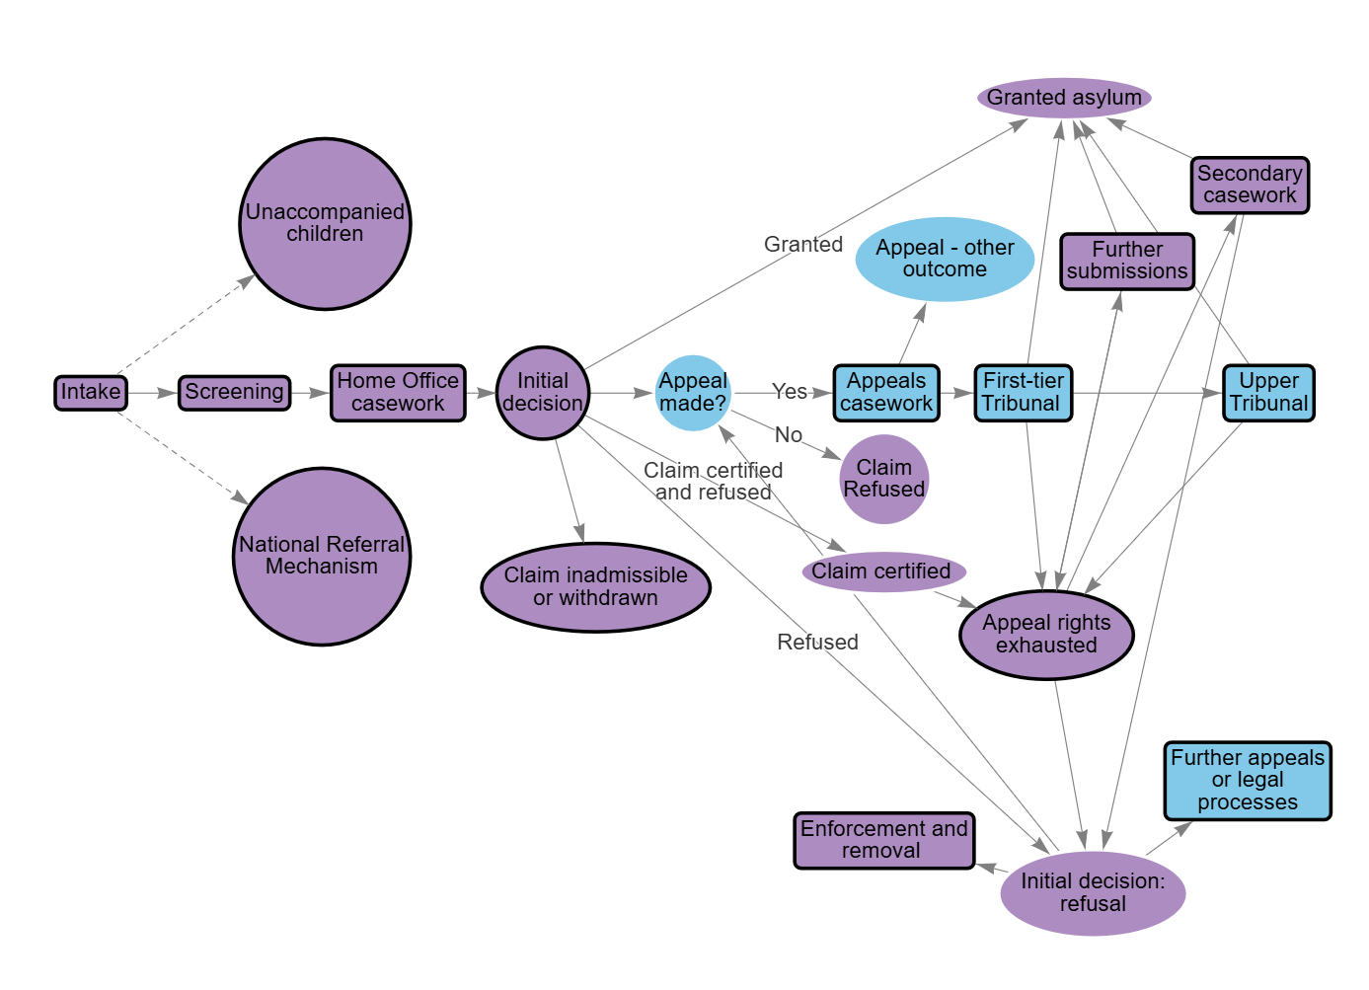

Accompanying text for demand and caseload in the asylum system

Intake
The number of people seeking asylum determines the overall pressure on the system, which experiences fluctuating volumes and significant peaks due to external factors. While the system cannot fully control the level of demand on it, operational decisions such as how cases are prioritised and resources allocated can influence how efficiently cases flow through the system and where bottlenecks are likely to emerge.
The number of people seeking asylum in the UK has increased since 2021. More than 109,300 people claimed asylum in the year ending March 2025. This is higher than the previous peak of around 99,300 in the year ending March 2003.
In 2024, the number of people seeking asylum represented around 11.4% of overall immigration to the UK and around 0.16% as a share of total UK population at mid-2024.

Home Office caseworking
Home Office caseworkers make the initial decision on an asylum claim after conducting an in-depth interview with the applicant and reviewing available evidence, including information about the applicant’s country of origin. The decision may result in the claim being granted or refused. In some cases, the claim is withdrawn by the applicant or declared inadmissible under Home Office rules.
In 2024-25, the Home Office made more than 94,100 initial decisions. As at 31 March 2025, just over 78,700 cases were awaiting an initial decision, of which around 24,500 had been waiting for more than 12 months.
The number of cases waiting for an initial decision has fallen since June 2023, reflecting Home Office efforts to reduce the backlog at the initial decision stage.

Appeals
Most asylum applicants whose cases are refused by the Home Office go on to appeal their decision, initially at the First-tier Tribunal (FTT). Data provided by the Home Office suggests that, of around 47,000 asylum applicants who received a refusal in 2024-25, around 32,000 (68%) went on to appeal. The appeals system is administered by the Ministry of Justice and HM Courts & Tribunals Service and is independent of the Home Office.
Appeals volumes have risen in recent years as cases refused during the Home Office's clearance of the backlog of initial decisions moved into the appeals system. In 2024-25, the FTT received around 40,700 appeals concerning asylum and protection cases and around 20,700 appeals concerning human rights cases. By March 2025, the FTT’s open caseload included nearly 51,000 asylum and protection appeals and 22,000 human rights appeals. This is almost five times higher than the caseload for these types of cases in 2019-20.

Claim Refused
When a claim is refused and the applicant has exhausted all their rights of appeal, the Home Office will usually begin to take enforcement action to attempt to remove the individual from the UK. During this time, applicants may be accommodated in the community or can be detained in Immigration Removal Centres. Some will also attempt to take further legal action, or to submit further information to the Home Office to prompt reconsideration of their claim. Removing people from the UK can be a challenging and time-consuming process, and many people spend long periods awaiting, and attempting to contest, their removal.

Figure detail for demand and caseload in asylum system - map

Secondary casework
Department group: Home Office
At the end of 2024, the Home Office's secondary caseworking team had around 4,900 cases awaiting a decision in their caseload.

Intake
Department group: Home Office
The number of people seeking asylum in the UK has increased since 2021. Around 109,300 people claimed asylum in the UK in the year ending March 2025, although around 15,400 claims were withdrawn in the same period. This is higher than the previous peak of around 99,300 asylum claims in year ending March 2003. In 2024, the number of people seeking asylum represented around 11.4% of overall immigration to the UK and around 0.16% as a share of total UK population at mid-2024. In the year to March 2025, around 36% of people seeking asylum arrived by small boat, while about 38% were already in the UK on a visa or entered with valid travel documentation.

Figure: The number of people claiming asylum from March 2002 to March 2025, and their route of entry to the UK, from March 2019 to March 2025
Year ending | Asylum claims lodged | Irregular arrivals | Visas and other leave | Other
Mar-02 | 74,892 | no data | no data | no data
Mar-03 | 99,338 | no data | no data | no data
Mar-04 | 51,649 | no data | no data | no data
Mar-05 | 38,261 | no data | no data | no data
Mar-06 | 30,121 | no data | no data | no data
Mar-07 | 27,593 | no data | no data | no data
Mar-08 | 29,322 | no data | no data | no data
Mar-09 | 33,948 | no data | no data | no data
Mar-10 | 25,657 | no data | no data | no data
Mar-11 | 23,304 | no data | no data | no data
Mar-12 | 26,010 | no data | no data | no data
Mar-13 | 28,803 | no data | no data | no data
Mar-14 | 30,485 | no data | no data | no data
Mar-15 | 32,371 | no data | no data | no data
Mar-16 | 42,599 | no data | no data | no data
Mar-17 | 37,663 | no data | no data | no data
Mar-18 | 34,668 | no data | no data | no data
Mar-19 | 41,057 | 22450 | 12000 | 7,100
Mar-20 | 44,884 | 24,700 | 12,500 | 8500
Mar-21 | 33,253 | 21900 | 8050 | 5500
Mar-22 | 69,038 | 52800 | 9860 | 9200
Mar-23 | 102,878 | 66200 | 23800 | 13800
Mar-24 | 93,150 | 44700 | 32800 | 15800
Mar-25 | 109,343 | 52000 | 41500 | 16,900

Notes:
- Figures showing the number of people claiming asylum by route of entry (bar charts) are drawn from a live Home Office database. As a result, there may be minor inconsistencies between these figures and the total number of asylum claims (line graph), so totals may not always exactly match.
- Figures for the number of people claiming asylum, by route of entry to the UK are rounded in the underlying Home Office data.
- Irregular arrivals relates to asylum claims from individuals who entered the UK without valid permission to enter (including via small boat or clandestine entry).
- From existing leave relates to asylum claims from individuals who entered the UK with relevant documentation on a visa or with other leave.
- Other relates to asylum claims from individuals who entered through other routes, are UK-born children of asylum seekers or refugees, or were non-visa nationals visiting the UK prior to the introduction of the ETA scheme, as well as claims which could not be matched to a route of entry.
- Published data on the route of entry to the UK is only available from the year ending March 2019.
Source: National Audit Office analysis of Home Office Immigration System Statistics

Screening
Department group: Home Office
The screening process gathers key information about an asylum applicant, including identity, family details, background, travel history, and health and welfare. Applicants also provide photographs and biometric data. Checks are carried out against the Police National Computer and the Warnings Index Control Unit, which holds records of previous immigration offences. Screening is essential for identifying vulnerabilities, safeguarding needs, security risks, and other factors that may affect how the case progresses. All information is stored in the Home Office’s ATLAS immigration system. If details are incomplete or inaccurate at this stage, it can lead to delays or errors later in the process.

Home Office casework
Department group: Home Office
When demand exceeds casework processing capacity, people wait longer for a decision on their asylum claim. At the end of March 2025, around 78,400 cases (relating to around 109,500 people) were awaiting an initial decision. Of these, around 24,500 cases had been pending for more than 12 months, compared with nearly 21,100 at the end of March 2024. The size and average age of the caseload have fluctuated over time due to changes in demand and shifts in prioritisation and case management approaches. For example, the Home Office is currently prioritising cases with associated support costs to reduce overall costs within the system.

Figure: Asylum cases awaiting an initial decision, by duration, from March 2020 to March 2025
As at the end of (month ending) | Total number of asylum cases waiting less than 3 months for an initial decision | Total number of asylum cases waiting 3-6 months for an initial decision | Total number of asylum cases waiting 6-12 months for an initial decision | Total number of asylum cases waiting more than 12 months for an initial decision
Mar-20 | 8,133 | 8,196 | 10,917 | 13,703
Mar-21 | 5,837 | 7,587 | 10,418 | 29,093
Mar-22 | 12,215 | 19,057 | 23,435 | 36,283
Mar-23 | 14,632 | 22,919 | 34,499 | 66,009
Mar-24 | 15,466 | 16,264 | 35,625 | 21,090
Mar-25 | 16,360 | 16,847 | 20,689 | 24,477
Source: National Audit Office analysis of Home Office Migration transparency data

Initial decision
Department group: Home Office
The latest available data on total cases in the asylum system shows that in June 2024 around 39% of cases were waiting for an initial decision. This share - and the absolute number of such cases - had fallen since June 2023, reflecting Home Office efforts to reduce the backlog at the initial decision stage. These changes indicate that demand within the system has shifted away from cases awaiting an initial decision towards those in the post-decision stages.

Appeals casework
Department group: Ministry of Justice
The Immigration and Asylum Chamber of the First-tier Tribunal (FTTIAC) is under significant pressure due to rising demand. Appeals volumes have risen in recent years, reflecting the Home Office’s efforts to clear its initial decision backlog. As of March 2025, the FTTIAC's open caseload included nearly 51,000 asylum appeal cases (an increase of 88% from March 2024) as well as nearly 22,000 cases based on Human Rights claims (an increase of 68% from March 2024), which together form the majority of its workload. Both the overall FTTIAC caseload and the number of asylum and protection cases have grown every year since 2020-21.

First-tier Tribunal
Department group: Ministry of Justice
Appeals to the Immigration and Asylum Chamber of the First-tier Tribunal (FTTIAC) rose sharply in 2024 and 2025, as cases refused during the Home Office's clearance of the backlog of initial decisions moved into the appeals system. In 2024-25, nearly 41,000 asylum appeals were submitted to the FTTIAC, up from around 29,000 in 2023/24 (a 39% increase) and 8,000 in 2022/23. Human rights appeals have also increased each year since 2020-21, with a marked rise in 2024-25. Together, these trends have contributed to the FTTIAC's overall caseload reaching more than 90,000 by March 2025. This increase in received appeals has outstripped the capacity of the tribunal system to meet the demand, resulting in the growing open caseload that was shown at the appeals casework stage.

Figure: Asylum appeals lodged at the First-tier Tribunal (Immigration and Asylum Chamber), from 2019-20 to 2024-25
Financial Year | Asylum related appeals lodged
2019-20 | 13,225
2020-21 | 6,900
2021-22 | 7,070
2022-23 | 8,019
2023-24 | 29,290
2024-25 | 40,667
Notes: In addition to Asylum appeals, these includes appeals relating to Protection and Revocation of Protection which were introduced as part of the Immigration Act 2014.
Source: National Audit Office analysis of Ministry of Justice tribunals statistics

Upper Tribunal
Department group: Ministry of Justice
Only a small share of asylum appeals reach the Upper Tribunal (UTIAC), but numbers have grown alongside the rise in First-tier Tribunal cases. In 2024-25, UTIAC received around 3,600 judicial review cases, up 21% from nearly 3,000 the previous year - although the data on this does not show what proportion of these involved an asylum claim. Over the same period, it concluded more judicial reviews than it received, reducing its open caseload to about 1,300 by year-end. The MoJ does not hold data on the total number of asylum cases received by the Upper Tribunal. The increase in cases reflects the surge in First-tier Tribunal activity, but still accounts for less than 2% of all open asylum and human rights appeals.

Figure: Tribunal Immigration and Asylum Chamber (UTIAC) judicial review receipts and open caseload, from 2019-20 to 2024-25
Financial Year | Total number of judicial review cases received by UTIAC (per financial year) | Total UTIAC cases (at financial year end)
2019-20 | 5,679 | 1,181
2020-21 | 1,870 | 645
2021-22 | 1,895 | 635
2022-23 | 2,320 | 1,076
2023-24 | 2,989 | 1,427
2024-25 | 3,630 | 1,304
Source: National Audit Office analysis of Ministry of Justice tribunals statistics

Claim inadmissible or withdrawn
Department group: Home Office
The Illegal Migration Act 2023 (IMA) introduced a new duty to remove people arriving or entering the UK illegally and added a provision that declared asylum claims made by those people were inadmissible, and that they could not be granted permission to remain in the UK. The then government put this into practice in July 2023 but, because its Rwanda scheme for removals was not live and it could not remove those people, the effect was to pause asylum decision-making in respect of individuals who had arrived in the UK illegally since 7 March 2023. Decision-making resumed for this cohort in July 2024, when the government passed regulations that removed the retrospective effect of the IMA. This created an additional backlog in initial asylum decisions, as the Home Office was now required to make a decision in the paused cases. Withdrawn cases are not included here as they represent an outcome, rather than a source of demand on the system. See the next map for more on these.

Figure: Number of people identified for consideration on inadmissibility grounds, from March 2021 to March 2025
Quarter | Total identified for consideration on inadmissibility grounds
2021 Q1 | 1,986
2021 Q2 | 3,356
2021 Q3 | 2,070
2021 Q4 | 3,102
2022 Q1 | 4,591
2022 Q2 | 6,073
2022 Q3 | 9,936
2022 Q4 | 14,600
2023 Q1 | 9,646
2023 Q2 | 5,202
2023 Q3 | 9,000
2023 Q4 | 7,643
2024 Q1 | 4,505
2024 Q2 | 7,104
2024 Q3 | 7,702
2024 Q4 | 2,626
2025 Q1 | 1,787
Source: National Audit Office analysis of Home Office Immigration System Statistics

Appeal rights exhausted
Department group: Home Office
The Home Office does not routinely monitor the number of people in the asylum system who are "appeal rights exhausted" and therefore subject to enforcement action. It told us that this is because enforcement activity and removal efforts are often complex and multi-layered, and because in many cases individuals are not definitively "appeal rights exhausted", and may be able to take further legal action in the future.

Further appeals or legal processes
Department group: Ministry of Justice
When people choose to pursue further action in their asylum claims, their cases will generally remain in the First-tier Tribunal or Upper Tribunal's caseload. Less frequently, cases may involve other jurisdictions, such as the criminal courts or High Court or Judicial Reviews. The Home Office does not currently record the number of Judicial Reviews that are submitted against it. The MoJ could not provide data on the number of cases involving an asylum claim that progressed into the Upper Tribunal, as its data was not recorded in a reportable form.

Enforcement and removal
Department group: Home Office
Home Office Immigration Enforcement does not hold a single figure for the number of people awaiting removal or subject to enforcement action. Instead, individuals enter caseworking systems when they do not have valid leave or when there is no record of departure. Individuals are only considered no longer of interest to Immigration Enforcement when their case is concluded, such as if they are granted leave, or are confirmed to have left the country. Immigration Enforcement can take a range of actions, including encouraging or enforcing departure from the UK, maintaining contact with the person or granting leave. Immigration Enforcement officials are also responsible for updating Home Office systems to confirm when people have left the UK, and deciding whether to revoke existing leave and pursue deportation in cases involving Foreign National Offenders. In the year ending March 2025, around 21,000 people were placed in immigration detention, 10% more than the previous year (19,000). Around 32% of these were asylum-related (around 6,800). At the end of March 2025, there were just over 1,800 people held in detention.

Further submissions
Department group: Home Office
In 2024-25, the Home Office received around 10,600 further submissions. This was significantly higher than the 7,000 further submissions it received in 2023-24.

National Referral Mechanism
Department group: Home Office
People enter the National Referral Mechanism (NRM) after being referred by a ‘first responder’ organisation, which includes some Home Office units. Cases are first assessed to determine if there are ‘reasonable grounds’ to believe the person is a victim of modern slavery. If this threshold is met, a further assessment decides whether there are ‘conclusive grounds’, allowing the individual to be formally recognised and receive support. In 2024–25, about 19,900 people were referred to the NRM - the highest number since its launch in 2009. The Home Office publishes nationality data for referrals but does not indicate whether these individuals also claimed asylum. While an NRM case is pending, removal from the UK cannot take place.

Unaccompanied children
Department group: Home Office
In the year to March 2025, around 3,700 unaccompanied asylum-seeking children (UASC) applied for asylum in the UK (3% of all applications). Applications peaked in 2022 (5,800) and have declined since. In 2024–25, most applicants were from Sudan and in 2024, 76% of UASC were aged 16–17. Screening differs from adults. UASC receive a welfare interview and checks to ensure they understand the process, and the Home Office must notify the relevant local authority children’s services as soon as possible. The Home Office must be satisfied an applicant is under 18 before progressing the asylum claim to ensure age-appropriate treatment and support. Misclassification can place children in the adult system without necessary protections. Staff receive specific guidance on assessing age.
Caseworking differences include:
- Decisions affecting the child must treat their best interests (UNCRC Article 3) as a primary consideration.
- Children recall experiences and express fears differently; evidence collected at interview must be considered in light of age, development and maturity.
- Specialist UASC caseworker teams handle children’s applications.
Children must receive the status they qualify for under the Immigration Rules; if Refugee Convention criteria are met, refugee status must be granted. Even where refugee status is not granted, all decisions - including any return - must consider the child’s best interests. A return can only proceed if safe and adequate reception arrangements are in place; otherwise, UASC Leave or Humanitarian Protection may be granted. UASC Leave is usually until age 17½ or for 30 months.

Demand and caseload in the asylum system – caseload chart

Figure detail for demand and caseload in asylum system – caseload chart

Figure: Asylum cases awaiting an initial Home Office decision, asylum appeals lodged to the First-tier Tribunal, and judicial reviews received by the Upper Tribunal, from 2020–21 to 2024–25
Financial year | Initial asylum decision (at financial year end) | Asylum appeals - First-tier Tribunal (per financial year) | Judicial reviews (per financial year)
2020-21 | 52,935 | 6,900 | 1,870
2021-22 | 90,990 | 7,070 | 1,895
2022-23 | 138,059 | 8,019 | 2,320
2023-24 | 88,445 | 29,290 | 2,989
2024-25 | 78,373 | 40,667 | 3,630
Source: National Audit Office analysis of Home Office immigration system statistics and Ministry of Justice tribunals statistics

Caseload in 2020-21
In 2020-21, the asylum system was affected by the COVID-19 pandemic. Restrictions on interviews and court hearings reduced the number of decisions and appeals progressed. At the end of the year, around 52,900 cases were awaiting an initial asylum decision by the Home Office, and the First-tier Tribunal received around 6,900 asylum appeals during the year.

Caseload in 2021-22
In 2021-22, the number of cases awaiting an initial asylum decision at year end increased by around 72% to nearly 91,000. During the year, the First-tier Tribunal received around 7,100 asylum appeals, while the Upper Tribunal received around 1,900 judicial review cases.

Caseload in 2022-23
In 2022-23, the number of cases awaiting an initial decision at year end rose to a peak of around 138,000, an increase of 52% compared with the previous year. During the year, appeals to the First-tier Tribunal also increased to nearly 8,000, a rise of around 13%.

Caseload in 2023-24
In 2023-24, appeals to the First-tier Tribunal rose sharply during the year as cases refused during the Home Office's clearance of the backlog of initial asylum decisions moved into the appeals system. At year end, the number of cases awaiting an initial decision by the Home Office fell to around 88,400, a 36% reduction compared with the previous year, while appeals rose to around 29,300, more than tripling compared with 2022-23. The Upper Tribunal received nearly 3,000 judicial review cases during the year, an increase of around 29% on the year before.

Caseload in 2024-25
In 2024-25, around 78,400 cases were awaiting an initial asylum decision at year end. During the year, appeals to the First-tier Tribunal continued to rise and reached nearly 40,700 asylum appeals, a 39% increase from the year before. The Upper Tribunal caseload also grew with around 3,600 judicial review cases, up by 21% from the previous year.

Decisions and outcomes in the asylum system
This map shows possible outcomes for people seeking asylum as they move through the system. It highlights decisions at each stage and the number of cases processed, illustrating how growing caseloads and backlogs have developed over time. For example, many people whose claims are refused go on to appeal, where they often face long delays. Overall, system capacity has not kept pace with demand. Efforts to reduce backlogs and speed up decisions in some areas have shunted pressure to other areas of the system.
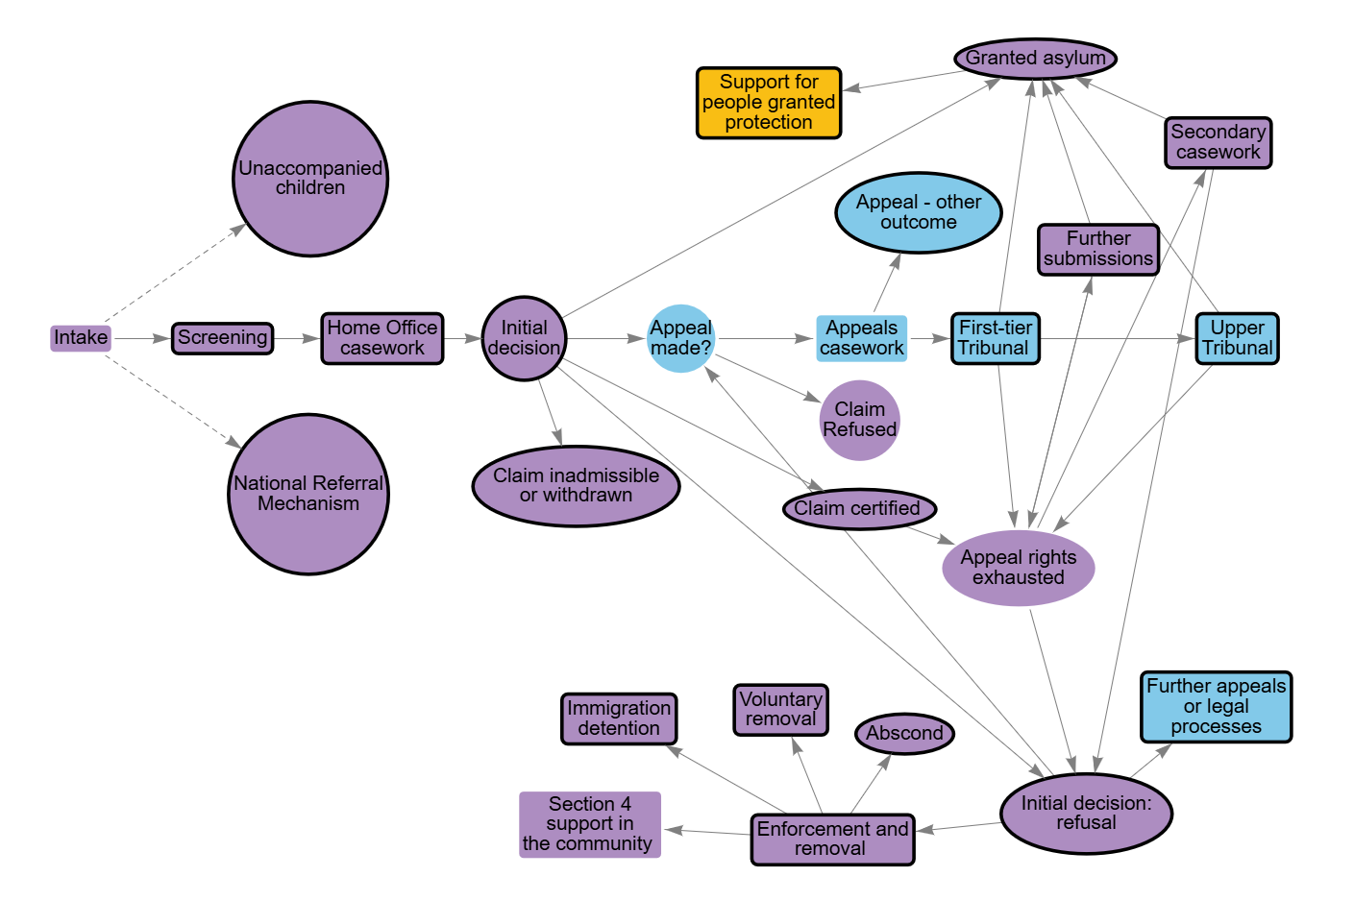

Accompanying text for decisions and outcomes in the asylum system
This map shows possible outcomes for people seeking asylum as they move through the system. It highlights decisions at each stage and the number of cases processed, illustrating how growing caseloads and backlogs have developed over time. For example, many people whose claims are refused go on to appeal, where they often face long delays.
Overall, system capacity has not kept pace with demand. Efforts to reduce backlogs and speed up decisions in some areas have shunted pressure to other areas of the system.
This version of the map also includes capacity details, such as workforce size and capacity of the tribunal estate limits, which affect processing speed.
The First-tier Tribunal decided on just over 26,000 cases in 2024-25, with the remainder of cases being completed by other means.
Most of the 2024-25 cases determined were either asylum and protection appeals (around 12,100) or based on human rights claims (around 7,600).
Additionally, around 3,000 asylum and protection appeals were withdrawn, along with around 3,000 human rights appeals. The Home Office now routinely reviews cases and withdraws them if it considers that the appeal is likely to be upheld.
When an individual is granted asylum, they then have a 28 day "move-on" period (56 days for family groups), after which they are no longer entitled to asylum support and may apply for accommodation via their local authority, and apply for benefits. This can place significant financial and logistical pressure on local authorities, who have a duty to provide suitable accommodation and support to eligible persons in line with homelessness legislation.
There are various outcomes for individuals whose asylum claims have been refused and who have no further appeal rights.
At March 2025, just over 4,200 people seeking asylum were receiving Section 4 support, which provides accommodation and financial support to meet basic living needs for people who have exhausted their appeal rights while they await further action.
In the year to March 2025, around 6,800 people who had previously claimed asylum entered detention, a 17% decrease compared with the previous year.
In the same period, just over 9,600 people who had previously claimed asylum were returned from the UK. Of these, almost 2,800 were enforced returns, an increase of 17% on the previous year, and nearly 6,900 were voluntary returns, up 36% compared with the year ending March 2024.

Detail for decisions and outcomes in the asylum system

Granted asylum
Department group: Home Office
When an individual is granted asylum, they then have a 28 day 'move-on' period (56 days for family groups), after which they are no longer entitled to asylum support and may apply for accommodation support via their local authority, and apply for benefits. This can place significant financial and logistical pressure on local authorities, who have a duty to provide suitable accommodation and support to eligible persons in line with homelessness legislation.

Secondary casework
Department group: Home Office
A number of cases need further processing by Home Office teams after the initial decision is made. In 2024, around 7,989 cases were decided by secondary casework teams after reviewing initial decisions.

Screening
Department group: Home Office
The Home Office does not routinely publish data on the number of screening interviews it has conducted.

Home Office casework
Department group: Home Office
In the year to March 2025, the Home Office made more than 94,100 initial decisions on asylum claims. This was around 15,200 fewer than the number of claims made in the same period and 16% fewer decisions (around 18,500) than in the year to March 2024, even though claims rose by 18%. In 2024–25, the Home Office employed just over 2,200 asylum caseworking staff.

Figure title: Initial asylum decisions made by the Home Office, from 2019 to the year ending March 2025
Year | Initial decisions made by Home Office
2019 | 28575
2020 | 19049
2021 | 18220
2022 | 23870
2023 | 94706
2024 | 84049
Year ending March 2024 | 112635
Year ending March 2025 | 94135
Notes: Years are shown as calendar years, except for those ending March 2024 and March 2025, which reflect the format in which the data are published.
Source: National Audit Office analysis of Home Office Immigration System Statistics

Initial decision
Department group: Home Office
In the year to March 2025, there were just over 94,100 initial decisions on asylum claims. Of these, nearly half of main applicants (around 45,100 or 48%) were given refugee status, human rights protection, or another type of permission to stay in the UK, with the remaining 52% (around 49,100) of claims being refused. Around 15,400 claims were withdrawn, of which 77% were implicit withdrawals - cases where the Home Office withdraws a claim because the applicant has failed to follow required processes, such as not attending interviews.
The overall grant rate has fluctuated over time. In 2019, it averaged 52%, rising steadily to a peak of 76% in 2022, before falling to 67% in 2023 and 47% in 2024.

Figure: Outcomes of Home Office's initial asylum decisions, from 2019 to year ending March 2025
Year | Grants of protection or other leave (for example, refugee status, human rights protection, or another type of permission to stay in the UK) | Refusals | Withdrawals
2019 | 15,080 | 13,495 | 3,563
2020 | 9,072 | 9,977 | 2,984
2021 | 13,103 | 5,117 | 3,083
2022 | 18,185 | 5,685 | 5,944
2023 | 63,008 | 31,698 | 26,301
2024 | 39,616 | 44,433 | 17,810
Year ending March 2024 | 69,032 | 43,603 | 26,379
Year ending March 2025 | 45,084 | 49,051 | 15,381
Notes: Years are shown as calendar years, except for those ending March 2024 and March 2025, which reflect the format in which the data are published.
Source: National Audit Office analysis of Home Office Immigration System Statistics

Appeal - other outcome
Department group: Ministry of Justice
In 2024/25, 16% of the asylum-related cases completed by the First-tier Tribunal were withdrawn. Another 2% were struck out for non-payment of the appeal fee, and 6% were found to be invalid or submitted out of time. The Home Office now routinely reviews cases and withdraws them if it considers that the appeal is likely to be upheld. However, HMCTS staff told us this does not always happen early enough to re-list other cases and make full use of court time.

Figure title: First-tier Tribunal appeal outcomes for asylum cases, from 2019-20 to 2024-25
Financial Year | Asylum related Tribunal disposals | Determined | Withdrawn | Struck Out | Invalid/Out of Time | Other
2019-20 | 14,642 | 90% | 7% | 0% | 3% | 0
2020-21 | 5,620 | 67% | 13% | 0% | 4% | 15%
2021-22 | 7,707 | 69% | 16% | 1% | 3% | 11%
2022-23 | 7,752 | 76% | 11% | 1% | 2% | 10%
2023-24 | 9,941 | 70% | 12% | 2% | 6% | 11%
2024-25 | 18,490 | 66% | 16% | 2% | 6% | 10%
Notes:
- In addition to Asylum appeals, these includes appeals relating to Protection and Revocation of Protection which were introduced as part of the Immigration Act 2014.
- Percentages may not sum to 100% exactly due to minor rounding differences in the underlying data.
- 'Other' includes appeals that could not be concluded using the online process, requiring it to be closed and restarted, and dual lodgement, where an appeal is lodged on paper but required to be resubmitted using the online procedure, mandated by Presidential Practice Statement No 2 of 2020.
Source: National Audit Office analysis of Ministry of Justice tribunals statistics

First-tier Tribunal
Department group: Ministry of Justice
In 2024-25, the First-tier Tribunal (FTTIAC) was projected to have 19,250 sitting days (the total time judges spent in tribunal). This is taken from MoJ's internal management information.
The FTTIAC decided on just over 26,000 cases in 2024-25, with the remainder of cases being completed by other means (for example see Appeal - other outcome).
Most of the 2024-25 cases that the FFTIAC determined were either asylum and protection appeals (around 12,100) or based on human rights claims (around 7,600). The tribunal upheld 45% of asylum and protection appeals and 50% of human rights claims.
Additionally, around 3,000 asylum and protection appeals were withdrawn, along with around 3,000 human rights appeals.
Around 24% of all listed hearings were adjourned or postponed during the year, meaning they were temporarily delayed.

Figure title: Number of asylum appeals determined at the First-tier Tribunal (FTTIAC), from 2019-20 to 2024-25
Financial Year | Asylum appeals determined by the FTTIAC | Asylum appeals granted by the FTTIAC
2019-20 | 13225 | 6348
2020-21 | 3788 | 1818.24
2021-22 | 5285 | 2589.65
2022-23 | 5887 | 2943.5
2023-24 | 6936 | 3329.28
2024-25 | 12139 | 5462.55
Notes: In addition to Asylum appeals, these includes appeals relating to Protection and Revocation of Protection which were introduced as part of the Immigration Act 2014.
Source: National Audit Office analysis of Ministry of Justice tribunals statistics

Upper Tribunal
Department group: Ministry of Justice
The Upper Tribunal determined nearly 3,000 cases in 2024-25, granting 26% overall. Outcomes varied by hearing type: 17% of cases reviewed on paper were granted, 86% of those considered through an oral renewal were granted, and 30% of cases that progressed to a substantive hearing were granted. It is not clear how many of these were cases involving an asylum claim as the data is not broken down in a manner which shows this.

Figure: Upper Tribunal (Immigration and Asylum) case outcomes, by consideration type, 2024-25
Outcome | Paper | Oral Renewal | Substantive hearing
Number of appeals determined | 2,529 | 359 | 67
Percentage of cases allowed or granted | 17% | 86% | 30%
Percentage of cases dismissed or refused | 83% | 14% | 70%
Number of cases certified Totally Without Merit | 109 | See Note | See Note
Notes: In refusing permission for judicial review, a judge can certify a case to be Totally Without Merit, which is where the judge considers there to be no arguable grounds for the claim and no realistic prospect of success. Totally Without Merit figures are only available for applications for permission to lodge judicial reviews dealt with on papers.
Source: National Audit Office analysis of Ministry of Justice tribunals statistics

Claim inadmissible or withdrawn
Department group: Home Office
Withdrawals rose sharply in 2023 and remained high in 2024.
The Home Office does not routinely publish data on the number of claims declared inadmissible.

Figure: Number of asylum claim withdrawals, from 2019 to year ending March 2025
Year | Withdrawals
2019 | 3,563
2020 | 2,984
2021 | 3,083
2022 | 5,944
2023 | 26,301
2024 | 17,810
Year ending March 2024 | 26,379
Year ending March 2025 | 15,381
Notes: Years are shown as calendar years, except for those ending March 2024 and March 2025, which reflect the format in which the data are published.
Source: National Audit Office analysis of Home Office Immigration System Statistics

Claim certified
Department group: Home Office
The Home Office certified and refused 5,800 claims in the year ending March 2025.

Further appeals or legal processes
Department group: Ministry of Justice
Ministry of Justice data does not break down applications for Judicial Reviews based on whether the case involves an asylum claim, and there is no published data on the number of asylum cases being heard in Higher Courts.

Enforcement and removal
Department group: Home Office
In the year to March 2025, just over 9,600 people who had previously claimed asylum were returned from the UK. Of these, almost 2,800 were enforced returns, an increase of 17% on the previous year, and nearly 6,900 were voluntary returns, up 36% compared with the year ending March 2024. In addition, 190 people who had previously claimed asylum were refused entry at a UK port and subsequently departed.
Home Office Immigration Enforcement (IE) are responsible for facilitating returns from the UK when an individual does not have a right to remain in the country. This can be done via casework carried out after a person is detained or, more commonly, through casework and enforcement activity against people living in the community. IE maintain a 'population of interest' consisting of people who are or may become removable, and prioritise cases based on the number and types of barriers involved in returns. The Home Office was not able to say how many people in its 'population of interest' had previously claimed asylum. It also does not hold data on the number of people refused asylum living in the community who were required to regularly report to the Home Office or the number of people who have claimed asylum and subsequently absconded from the immigration system.

Initial decision: refusal
Department group: Home Office
Around 43,300 asylum claims were refused in the year ending March 2025 (not including claims that were certified and refused).

Voluntary removal
Department group: Home Office
Over the 12 months to March 2025, there were almost 6,900 voluntary removals of individuals who had previously claimed asylum.

Abscond
Department group: Home Office
The Home Office do not hold data on the number of people who have absconded from the immigration system, who have previously claimed asylum.

Support for people granted protection
Department group: Local authorities
There is currently no published data on the number of people granted protection who go on to receive move-on support.

Immigration detention
Department group: Home Office
Over the 12 months to March 2025, around 6,800 people who had previously claimed asylum were placed in immigration detention, and around 7,300 were released from detention during the same period. These figures do not necessarily refer to the same individuals, as some people detained before this period may have been released later. At the end of March 2025, just over 1,800 people remained in detention, although due to the nature of Home Office data it was not possible to say how many of these 1,800 had previously claimed asylum. In 2024-25, the average time in detention for an individual who was not a Foreign National Offender was around 28 days, whereas the average time in detention for an individual who had previously been convicted of a criminal offence was around 69 days.

Further submissions
Department group: Home Office
In cases where an applicant believes they have new evidence to support their claim, or that their personal circumstances have changed, they can submit further evidence for the Home Office to consider. In 2024-25, the Home Office made around 9,600 decisions on further submissions. This is significantly higher than the 6,100 decisions it made on further submissions in 2023-24. The Home Office was not able to provide data on the outcomes of further submissions.

National Referral Mechanism
Department group: Home Office
In 2024-25, 10,500 people were found to have 'reasonable grounds' to be considered as a victim of modern slavery after being referred to the NRM. Around 11,300 people were judged to have 'conclusive grounds' meaning that they were judged to be a victim of modern slavery - some of these reasonable grounds and conclusive grounds decisions will have pertained to the same people as they moved through the system. The Home Office does not publish how many of these people had previously or also claimed asylum.

Unaccompanied children
Department group: Home Office
In the year ending March 2025, the Home Office made around 4,600 initial decisions on applications from unaccompanied asylum-seeking children (UASC), down from 6,700 the year before. Of these, around 3,400 led to refugee status, human rights protection, or other leave. The grant rate has varied over time - 69% in 2018, peaking at 90% in 2021, and 74% in 2025.
Where an applicant’s age cannot be established, the Home Office raises an age dispute, either at the border or after a claim is lodged. There has been a rise in age disputes, with around 6,300 cases raised in the year ending June 2024 (+21% on the year ending June 2023). For age disputes resolved in the year ending June 2024, 60% were found to be under 18. Between January and June 2024, 63 local authorities in England and Scotland received around 600 referrals about young people placed in adult accommodation following Home Office age assessments; of the nearly 500 cases later verified, 53% were found to be under 18.
Unaccompanied children are rarely forcibly returned, and only where safe reception in the country of origin is confirmed. Those who choose to return voluntarily may receive assistance. Overall return statistics may include former UASC who turned 18 and were later removed, but these cases cannot be disaggregated.

Figure: Home Office age disputes resolved for unaccompanied asylum-seeking children, from 2019 to year ending June 2024
Year | Under 18 age disputes resolved | 18 and over age disputes resolved
2019 | 62% | 38%
2020 | 48% | 52%
2021 | 51% | 49%
2022 | 51% | 49%
2023 | 73% | 27%
Year ending June 2023 | 58% | 42%
Year ending June 2024 | 60% | 40%
Notes: Years are shown as calendar years, except for those ending June 2023 and June 2024, which reflect the format in which the data are published.
Source: National Audit Office analysis of Home Office Immigration System Statistics

Journeys through the asylum system
This section shows the different paths an asylum claim can take, based on a sample of actual journeys.
The data comes from 5,000 individuals who claimed asylum in January 2023. The Home Office provided us with information about the date at which each of these cases hit key milestones within the asylum system, allowing us to identify common routes and the time taken to progress through the system.
Due to data limitations, we can only show high-level outcomes (for example, further submission made to the Home Office and eventual decision), not detailed steps in each journey.
These cases were lodged in January 2023, before several major legislative and system changes. This is therefore an illustration of possible paths and where delays may occur, not a guide to current processing times.

Accompanying figure and text for journeys through the asylum system – Sankey

Figure: Pathways and outcomes for a sample of 5,000 asylum claims raised in 2023
Pathway or outcome | Total cases
Application Raised, January 2023 | 5000
Initial decision - granted | 1551
Initial decision - refused RoA | 1278
Initial decision - refused certified | 290
Withdrawn, disqualified, or suspended | 1816
Initial decision - other outcome | 16
No initial decision outcome | 49
Appeal lodged | 1036
Further submissions made to the Home Office | 275
Granted (refugee status) | 1619
Granted humanitarian protection | 75
Granted (limited leave) | 41
Case not marked as concluded on management system | 2812
Returned | 452
From: Application Raised, January 2023 To: Initial decision - granted | 1551
From: Application Raised, January 2023 To: Initial decision - refused RoA | 1278
From: Application Raised, January 2023 To: Initial decision - refused certified | 290
From: Application Raised, January 2023 To: Withdrawn, disqualified, or suspended | 1816
From: Application Raised, January 2023 To: Initial decision - other outcome | 16
From: Application Raised, January 2023 To: No initial decision outcome | 49
From: Initial decision - granted To: Appeal lodged | 19
From: Initial decision - granted To: Granted (refugee status) | 1454
From: Initial decision - granted To: Granted humanitarian protection | 51
From: Initial decision - granted To: Granted (limited leave) | 26
From: Initial decision - refused RoA To: Appeal lodged | 964
From: Initial decision - refused RoA To: Further submissions made to the Home Office | 18
From: Initial decision - refused RoA To: Case not marked as concluded on management system | 261
From: Initial decision - refused RoA To: Returned | 28
From: Initial decision - refused certified To: Appeal lodged | 18
From: Initial decision - refused certified To: Further submissions made to the Home Office | 97
From: Initial decision - refused certified To: Case not marked as concluded on management system | 125
From: Initial decision - refused certified To: Returned | 48
From: Withdrawn, disqualified, or suspended To: Appeal lodged | 33
From: Withdrawn, disqualified, or suspended To: Further submissions made to the Home Office | 21
From: Withdrawn, disqualified, or suspended To: Granted (refugee status) | 115
From: Withdrawn, disqualified, or suspended To: Case not marked as concluded on management system | 1369
From: Withdrawn, disqualified, or suspended To: Returned | 277
From: Initial decision - other outcome To: Case not marked as concluded on management system | 11
From: No initial decision outcome To: Case not marked as concluded on management system | 41
From: Appeal lodged To: Further submissions made to the Home Office | 43
From: Appeal lodged To: Granted (refugee status) | 133
From: Appeal lodged To: Granted humanitarian protection | 23
From: Appeal lodged To: Granted (limited leave) | 15
From: Appeal lodged To: Case not marked as concluded on management system | 791
From: Appeal lodged To: Returned | 31
From: Further submissions made to the Home Office To: Case not marked as concluded on management system | 214
From: Further submissions made to the Home Office To: Returned | 60

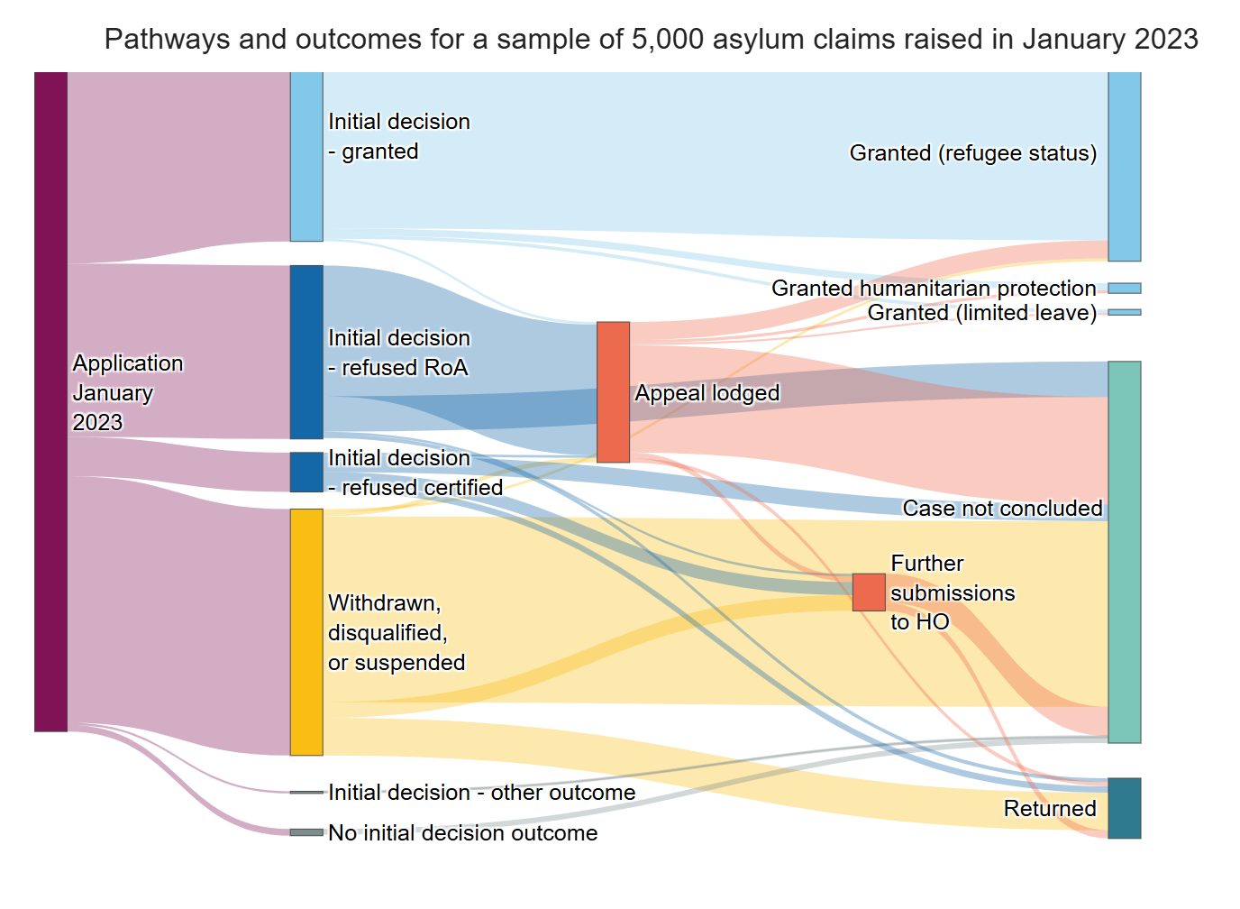
The graphic shows how the 5,000 people seeking asylum in our sample progressed through the asylum system and their final outcomes. You can trace the different paths individuals followed and see the proportion that experienced each outcome. Each stream represents interactions with key milestones in the process, such as the initial decision, whether an appeal was lodged, and whether further submissions were made.
The width of a stream indicates volume, with wider flows meaning more people. Hovering over any stream reveals the number of people in that group and how many moved between the milestones, such as cases where an appeal was lodged and later granted.
On the right, the outcomes reflect the status of these asylum claims as of September 2025. We have removed streams that represent fewer than 10 individuals. This means that the total number of people reaching an outcome might not equal the sum of the component streams.
Overall, 35% of people in our sample were granted protection as the final outcome of their case; 32% were granted refugee status and a further 2% received humanitarian protection or limited leave.
Among people whose claims were refused but who had a right of appeal (26% of our sample), three-quarters went on to lodge an appeal. Some of these may also have progressed to the Upper Tribunal; however, we cannot quantify this proportion due to data limitations.
Many of these individuals are still awaiting an appeal decision. Only a small proportion (15%) have so far had their case concluded with a successful outcome and were then granted refugee status or another form of protection.
Claims that are certified are judged as "clearly unfounded" by the Home Office and refused at initial decision. They do not have a right of appeal, but may make a further submission.
Approximately 450 people were returned after their asylum applications were unsuccessful. This represents just 18% of all people with refused or invalid claims, excluding those where appeals are ongoing or further submissions have been made to the Home Office.
More than half of the people in our sample (56%) still do not have a final outcome. Of these, 25% are awaiting an appeal decision and 3% involve further submissions. The remaining open claims - around two-thirds - are not being progressed, and the individuals involved have not been removed from the UK.
The Home Office does not hold data on how many people linked to refused claims are living in the community and required to report regularly, nor on how many have absconded from the immigration system. It also does not know how many of these individuals continue to receive accommodation or other support.

Accompanying figure and text for journeys through the asylum system – time figure
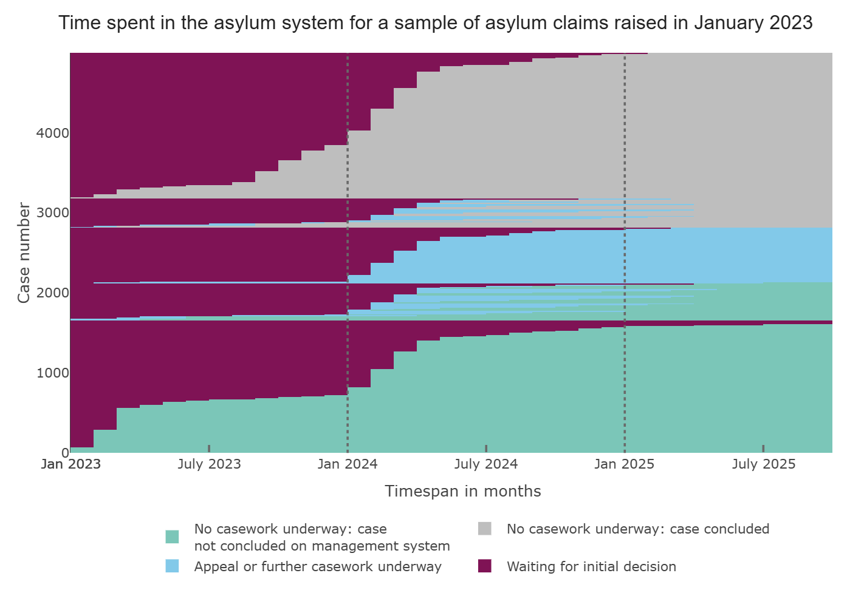
This graphic illustrates how long individuals in our sample spent at different stages of the asylum process. The vertical axis shows all 5,000 individuals in our sample in January 2023, and the horizontal axis shows the time they spent waiting between processes. The cases are organised into cohorts who have similar process interactions and their status as of September 2025. Hovering over the graphic shows how many months the stage took for the individual row highlighted.
In the graphic you can see the number of individuals receiving initial decisions and secondary decisions over time, and the proportion of cases that are concluded and unconcluded as of September 2025.
More than half the people in our sample (56%) have not yet had their claim resolved by September 2025, after an initial application made in January 2023.
Nearly 35% of people in our sample received an initial decision within 12 months, and half (50%) waited 13 months or less. However, a small proportion of claims (3%) were still awaiting an initial decision after two years.
Waiting times in the appeals system were significantly longer. 1,036 cases out of the 5,000 sample lodged an appeal.
Around two-thirds of people who had lodged an appeal were still awaiting a decision at the end of the sample period in September 2025. For appeals that had been concluded already, the median waiting time was 10 months.
The claims of 41% of people in our sample remain open but are not awaiting an appeal decision or the outcome of further submissions to the Home Office. These claims are not being progressed, and the individuals involved have not been removed from the UK. A third of these individuals have been waiting more than two years since the last decision in their case, whether at the initial decision stage or following an appeal.
The data presented is drawn from a sample of 5,000 individuals who made an asylum claim in January 2023. We received the sample data towards the end of September 2025. The data contained information about the date cases hit key milestones within the asylum system and their current status on the case management system.
We used milestone dates to count the number of cases that passed through each stage, which allowed us to generate the flows shown in the Sankey diagram. The current status recorded in the case management system was also incorporated to complete the picture.
For the duration chart, we calculated the time between milestone dates and rounded the difference in days to the nearest month. Any case that lodged an appeal, made a further submission, or had additional casework by the Home Office was treated as having a subsequent decision following the initial decision.
We grouped the sample into cohorts of cases that experienced the same processes and case statuses to produce the final figure.

Accommodation and support in the asylum system
This section shows the different types of accommodation and support in use within the asylum system, and the number of people accessing different types of support. The Home Office provides financial support and accommodation to destitute people seeking asylum.
There are several legal forms of support available as individuals progress through the asylum system:
- Section 98 support - short-term assistance for those who have just claimed asylum.
- Section 95 support - for people seeking asylum awaiting an initial decision or who have lodged an appeal against a decision.
- Section 4 support - for individuals whose claim has been refused and who have exhausted appeal rights.
People seeking asylum may also be detained at certain points in the process.
The type of support depends on individual circumstances. People seeking asylum who would otherwise be destitute typically receive accommodation and a weekly cash allowance of £49.18 for basic expenses (£9.95 for those in catered accommodation). Those with alternative accommodation, for example with a family member in the UK, may only receive cash support. All people seeking asylum are entitled to healthcare, and education for children up to the age of 17.
Unaccompanied children are cared for by local authorities, funded by the Home Office. Information about the asylum system for unaccompanied children is included in this iteration of the map.
The journey through the support system is not linear. Individuals can switch between different types of support as they journey through the system.
Growing demand for asylum services has increased pressure on support and accommodation. Delays in other parts of the system, such casework, appeals, and removals further exacerbate this demand.
In particular, the demand for dispersal accommodation has outstripped supply. The Home Office competes for housing in a market already under strain from high demand for social housing. As a contingency, the Home Office has increasingly relied on hotels, which are significantly more expensive. Hotel accommodation cost £2.1bn in 2024-25, whereas dispersal accommodation (which is generally houses or flats, which may be shared) cost £0.55bn in the same period.
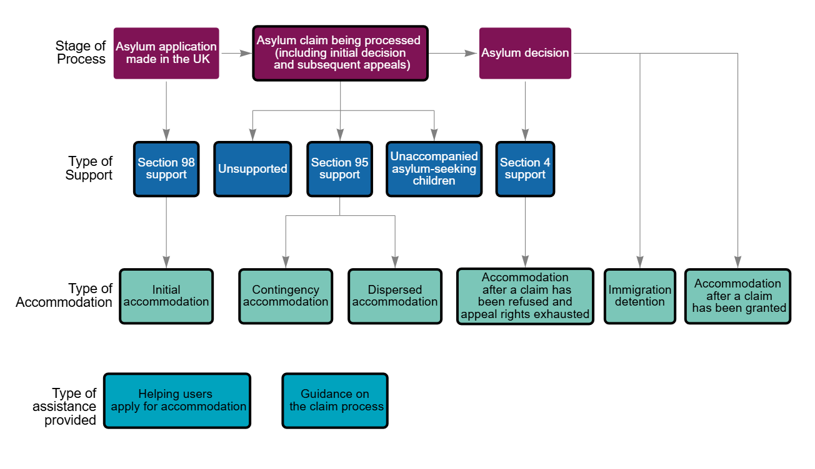

Accompanying text for accommodation and support in the asylum system
The Home Office is responsible for asylum and protection in the UK.
The Home Office provides support and accommodation to people seeking asylum who would otherwise be destitute. The nature of this support and accommodation depends on the individual circumstances of the person seeking asylum, demand in the system overall, and the stage of the system the case is currently at.
At the end of March 2025, there were around 106,800 people seeking asylum receiving some form of support in the UK, and almost all of these (around 103,700) were living in asylum accommodation. The majority of people receiving support (around 102,530) were receiving Section 95 or Section 98 support. The majority of these were awaiting a decision on either an asylum claim or an appeal. Of all accommodated people seeking asylum, around 32,300 (30%) were in hotels and around 71,300 (67%) were in other accommodation, including initial, contingency and dispersal accommodation. The North East and North West regions supported the largest number of people seeking asylum as a proportion of their overall population.
At the end of March 2025, around 4,200 people were receiving Section 4 support in the community after exhausting their appeal rights. Over the 12 months to March 2025, around 6,800 people who had previously claimed asylum were placed in immigration detention, and around 7,300 were released from detention during the same period. At the end of March 2025, there were around 1,800 people in detention but it was not clear what proportion of those had previously claimed asylum or were currently claiming asylum.
While the Home Office publishes data on the number of supported people seeking asylum living in each region of the UK, there is no available data on where individuals whose claims have been granted are located and which local authorities are responsible for providing suitable accommodation. Statutory homelessness data for England shows that between January and March 2025, 1,920 households were entitled to support to prevent homelessness after being required to leave Home Office accommodation - up 47% on the same quarter in the previous year. In the same period, 4,020 households were entitled to support to relieve homelessness, a 19% decrease compared to January to March 2024. The Ministry for Housing, Communities and Local Government have published data showing that, in June 2025, there were 321 individuals seen rough sleeping following their departure from asylum accommodation, a 62% increase compared to the previous year.
Spreading people seeking asylum across the UK has meant that they are dispersed more evenly across different local authorities, but has also meant that individuals have been placed in areas that have limited experience of supporting people in the asylum system, and are potentially lacking resources, practice, or local support. This can also place pressure on local services such as schools and healthcare.
Unaccompanied asylum-seeking children (UASCs) are children who are under 18 years old when their asylum claim is lodged, and who are not being cared for by a parent or responsible adult. These children are entitled to different forms of support as they go through the asylum system, and are treated as looked-after children and placed into the care of a local authority while their claim is processed. At the end of March, around 3,700 asylum claims were from unaccompanied children. The Home Office provides grant funding to local authorities to fund their care.

Figure detail for accommodation and support in the asylum system

Asylum claim being processed (including initial decision and subsequent appeals)
During this time, an individual's journey through the support system may not be linear. The type of accommodation and support provided to them may change, and support may stop and resume at a later date. At present, Home Office data can only show how many people are receiving different types of support at a particular moment in time, and not an individual's journey through the support system.

Section 98 support
Section 98 support is temporary support given to people who have just claimed asylum. Section 98 support ceases when an individual's application for Section 95 support is decided. Most section 98 accommodation is fully catered and individuals receive an additional £9.95 per person per week to support themselves.
By the end of March 2025, 1,600 people were receiving Section 98 support.

Figure title: Number of people in receipt of Section 98 support, from 2019 to year ending March 2025
Year | Section 98
2019 | 2,738
2020 | 12,235
2021 | 24,175
2022 | 49,493
2023 | 1,244
2024 | 3,189
Year ending March 2024 | 1,784
Year ending March 2025 | 1,600
Notes:
- Years are shown as calendar years, except for those ending March 2024 and March 2025, which reflect the format in which the data are published.
- Before 31 December 2022, data for people accommodated while their initial asylum claim was assessed did not distinguish between those in initial accommodation and those in contingency accommodation.
Source: National Audit Office analysis of Home Office Immigration System Statistics

Section 95 support
Section 95 support refers to support - including accommodation, cash support, or a combination of both - provided to people seeking asylum who would otherwise be destitute while their claim is being decided.
At the end of March 2025, around 100,900 people were receiving Section 95 support - around 2,600 (3%) more than in March 2024 and significantly more than in 2022. Section 95 accounted for about 95% of all asylum support cases.
Most recipients live in dispersal housing, though some remain in hotels or initial accommodation while longer-term options are arranged. This has created significant pressure on local authorities and community services, particularly in areas hosting the largest numbers. Local authorities report strain on housing, healthcare and education services.
Section 95 accommodation may be full-board or self-catered. In 2025, financial support was £49.18 per person per week via a pre-loaded payment card for essentials. Where meals are provided, this is reduced to £9.95 per week.

Figure title: Number of people in receipt of Section 95 support, from 2019 to year ending March 2025
Year | Section 95
2019 | 43,549
2020 | 45,626
2021 | 54,669
2022 | 55,817
2023 | 105,978
2024 | 104,931
Year ending March 2024 | 98,349
Year ending March 2025 | 100,930
Notes: Years are shown as calendar years, except for those ending March 2024 and March 2025, which reflect the format in which the data are published.
Source: National Audit Office analysis of Home Office Immigration System Statistics

Unsupported
Some people seeking asylum do not receive formal Home Office support. This may be because they are ineligible, have chosen to self-support, or their support ended after a refused claim. These individuals often rely on personal savings, help from charities, or support from family. The Home Office was not able to provide data on the number of people seeking asylum currently not receiving any support from the state.

Unaccompanied asylum-seeking children
An unaccompanied asylum-seeking child is defined by the Immigration Rules as a child who is under 18 years of age at the time they submit their asylum claim, is applying for asylum in their own right, and is separated from both parents and is not being cared for by an adult who in law or by custom has responsibility to do so. Being unaccompanied is not necessarily a permanent status and may change, for example if the child has family members in the UK.
UASC in the UK are looked after by local authorities. They provide accommodation, healthcare, access to education and other support. By the end of March 2025, local authorities were responsible for a total of 6,540 UASC, compared to 4,150 at the end of March 2021.
The National Transfer Scheme (NTS) facilitates the movement of UASC between local authorities to prevent disproportionate responsibility falling on specific areas. In the year ending March 2025, around 2,500 UASC were transferred from one local authority to another. However, arrival areas such as Kent continue to look after the highest number of UASC, placing sustained pressure on certain authorities.
The Home Office makes funding available to support local authorities, with payments calculated per person per night. The amount varies depending on the number of UASC housed by each authority. Local authorities receive £143 per night per child if they support a high proportion of unaccompanied asylum-seeking children (above the 0.07% threshold), and £114 per night per child if they are below that threshold. Transfers under the National Transfer Scheme are funded at the higher rate regardless of the receiving authority’s threshold status.
While in the asylum system, UASC are placed in different types of accommodation depending on their age. Children under the age of 16 are typically placed in foster care or residential care homes. Those aged 16 and over are usually accommodated in semi-independent living units or supported lodgings. Hotel accommodation or housing shared with adults is not considered suitable for unaccompanied children. In the year ending March 2025, 56% of unaccompanied asylum-seeking children were placed in supported accommodation, 38% in foster care, 1% in children’s or secure homes, and 5% in other placements, including semi-independent arrangements not registered with Ofsted. These numbers reflect the age of the majority of UASC (over 16).
Upon UASC turning 18, the Home Office automatically ceases standard funding payments. Thereafter, support continues under the Care Planning and Care Leavers Regulations. Local authorities remain responsible for the care of the young person. For UASC who have received a form of leave to remain, the Home Office provides Care Leaver Funding to local authorities of £270 per week. If leave has been denied, UASC move into Section 4 support. Delays in immigration status decisions and limited return options mean that local authorities must continue to support UASC care leavers beyond the age of 18.
Figure: Children looked after who were unaccompanied asylum-seeking children, by placement type, from year ending March 2021 to March 2025
Date | Total | Foster placements | Secure homes and children's homes | Independent and semi-independent living arrangements/ supported accommodation | Other placements
Mar-21 | 4,150 | 1,970 | 40 | 2,110 | 20
Mar-22 | 5,680 | 2,240 | 40 | 3,370 | 30
Mar-23 | 7,410 | 2,780 | 80 | 4,420 | 130
Mar-24 | 7,440 | 2,740 | 90 | 3,240 | 1,370
Mar-25 | 6,540 | 2,460 | 70 | 3,650 | 350

Notes: From 2024, young people who were placed in former semi independent and independent living placements with providers who had not submitted a completed application by the deadline are reported within the 'Other' category.
Source: National Audit Office analysis of Department for Education statistics on looked-after children

Section 4 support
Section 4 support is for people whose asylum claims have been refused, are appeal rights exhausted, and cannot meet essential living needs. Applicants must show destitution and meet one of several conditions: taking reasonable steps to leave the UK, being unable to travel due to medical reasons, having no safe route of return, having permission for Judicial Review, or needing support to avoid a human rights breach.
At the end of March 2025, around 4,200 people were receiving Section 4 support, accounting for about 4% of all asylum support cases.
Accommodation may be full-board or self-catered. In 2025, support was £49.18 per person per week via a pre-loaded payment card for essentials, reduced to £9.95 where meals are provided.
Figure: Number of people in receipt of Section 4 support, from 2019 to year ending March 2025
Year | Section 4
2019 | 3,804
2020 | 6,180
2021 | 5,613
2022 | 4,861
2023 | 3,910
2024 | 4,067
Year ending March 2024 | 4,166
Year ending March 2025 | 4,241
Notes: Years are shown as calendar years, except for those ending March 2024 and March 2025, which reflect the format in which the data are published.
Source: National Audit Office analysis of Home Office Immigration System Statistics

Initial accommodation
Initial accommodation is provided by the Home Office while assessing whether ongoing support is needed. It is usually in hotels or hostels, where meals are included. At March 2025, around 1,700 people were in initial accommodation.

Contingency accommodation
Contingency accommodation is used when there is not enough dispersed housing in local authority areas. It mainly consists of hotels and large sites. Most people are eventually moved from contingency accommodation into dispersed accommodation once this becomes available.
At the end of March 2025, around 35,000 people were in contingency accommodation.

Figure title: Number of people living in contingency and dispersal accommodation, from December 2022 to March 2025
Month ending | Dispersal accommodation | Contingency accommodation (hotel and other)
Dec-22 | 56,143 | 47720
Mar-23 | 56,979 | 49606
Jun-23 | 58,636 | 52659
Sep-23 | 58,444 | 58469
Dec-23 | 56,489 | 47778
Mar-24 | 61,230 | 37172
Jun-24 | 61,778 | 32043
Sep-24 | 65,311 | 38380
Dec-24 | 65,707 | 41078
Mar-25 | 66,683 | 34664
Jun-25 | 66,234 | 34314
Source: National Audit Office analysis of Home Office Immigration System Statistics

Dispersed accommodation
Dispersed accommodation typically consists of houses or flats in local authority areas.
At the end of March 2025, around 66,700 people were living in dispersal accommodation - around 34,300 more than were accommodated in hotels at the same time. Most were located in the North West and Midlands of England.

Figure: Number of people living in contingency and dispersal accommodation, from December 2022 to March 2025
Month ending | Dispersal accommodation | Contingency accommodation (hotel and other)
Dec-22 | 56,143 | 47720
Mar-23 | 56,979 | 49606
Jun-23 | 58,636 | 52659
Sep-23 | 58,444 | 58469
Dec-23 | 56,489 | 47778
Mar-24 | 61,230 | 37172
Jun-24 | 61,778 | 32043
Sep-24 | 65,311 | 38380
Dec-24 | 65,707 | 41078
Mar-25 | 66,683 | 34664
Jun-25 | 66,234 | 34314
Source: National Audit Office analysis of Home Office Immigration System Statistics

Accommodation after a claim has been granted
The Home Office requires people to leave its accommodation within 28 days of receiving a positive asylum decision, and provides funding to local authorities for supporting people to find suitable housing. A pilot extended this ‘move-on’ period to 56 days between December 2024 and August 2025, but it has now reverted to 28 days for all single adults. It remains 56 days for families and adults who are pregnant, over the age of 65, or have a disability. Outside of this formalised support, people granted protection can now access services in the same way as anyone else living in the community, and may approach the local authority with any additional support needs.
Rising asylum grants have increased pressure on local authorities to secure housing, creating risks of homelessness and rough sleeping. Statutory homelessness data for England shows that between January and March 2025, 1,920 households were entitled to support to prevent homelessness after being required to leave Home Office accommodation - up 47% on the same quarter in the previous year. In the same period, 4,020 households were entitled to support to relieve homelessness, a 19% decrease compared to January to March 2024.
The Home Office is working to share more data with local authorities to improve visibility of people moving in and out of their communities.

Accommodation after a claim has been refused and appeal rights exhausted
People whose asylum claims have failed and who have exhausted appeal rights can remain in accommodation if they are destitute and qualify for Section 4 support. Most are housed in the community, but some individuals may be detained prior to removal.

Immigration detention
As of 31 March 2025, around 1,800 people were held in immigration detention in the UK - 6% fewer than the previous year. Most people detained under Immigration powers are detained in the immigration detention estate rather than prisons.
In 2024-25, the average detention length for people who had previously claimed asylum was around 37 days, compared to 43 days in 2023-24 and 27 days in 2022-23. This covers Immigration Removal Centres and Residential Short-Term Holding Facilities.

Figure title: Number of people held in immigration detention, from March 2019 to March 2025
Month ending | Total number of people held in immigration detention
Mar-19 | 1,839
Jun-19 | 1,727
Sep-19 | 1,826
Dec-19 | 1,637
Mar-20 | 895
Jun-20 | 698
Sep-20 | 990
Dec-20 | 910
Mar-21 | 1,033
Jun-21 | 1,550
Sep-21 | 1,410
Dec-21 | 1,179
Mar-22 | 1,440
Jun-22 | 2,038
Sep-22 | 2,077
Dec-22 | 1,159
Mar-23 | 1,591
Jun-23 | 1,924
Sep-23 | 1,841
Dec-23 | 1,782
Mar-24 | 1,913
Jun-24 | 1,788
Sep-24 | 1,748
Dec-24 | 1,940
Mar-25 | 1,806
Source: National Audit Office analysis of Home Office Immigration System Statistics

Helping users apply for accommodation
The national Advice, Issue Reporting and Eligibility service (AIRE) can support users to apply for Section 95 accommodation.

Guidance on the claim process
The national Advice, Issue Reporting and Eligibility service (AIRE) can provide guidance on the claim process, an induction service to explain the accommodation and support provided, and an issue reporting service to allow users to raise issues about their accommodation.

Cost of the asylum system
There is no overall cross-government budget for the asylum system. The Home Office allocates a specific budget for certain asylum-related costs, such as accommodation and support. Caseworking staff costs are recorded within other budgets as actual spend, while costs associated with appeals and detention are calculated on an estimated basis. Spending by other parts of government is incorporated into their wider budgets for the justice system, housing, education or other types of support.

Figure detail for cost of the asylum system

Accommodation and support
Cost: £3,406m
In 2024-25, the Home Office spent around £3.4 billion on asylum accommodation and support (excluding on unaccompanied asylum-seeking children). This includes around £220 million on cash support provided to those seeking asylum, as well as around £247 million in grants and additional payments paid to local authorities for dispersal accommodation.
In 2024-25, the Home Office spent around £52 million on initial accommodation; £545 million on dispersal accommodation in local authority areas; £2.1 billion on hotel accommodation; and around £7 million on other forms of accommodation including large sites.

Unaccompanied children
Cost: £636m
Local authorities receive Home Office funding to help meet the costs of caring for unaccompanied asylum-seeking children (UASC) and former UASC care leavers. In 2024–25, rates ranged from £114 to £143 per child per night, depending on the proportion of UASC in care, with higher rates for authorities taking more children or transfers under the National Transfer Scheme. Funding for eligible former UASC care leavers was £270 per person per week.
In 2024-25, the Home Office spent around £636 million on grants and incentive payments to local authorities for UASC and former UASC care leavers.
Some local authorities noted that while these grants help with placement and care costs, they do not always cover the full cost of provision, particularly for children with complex needs. The Home Office noted that these grants are not designed to represent a full cost recovery, and are paid in addition to other funding for children's social care received by local authorities.

Intake and asylum casework
Cost: £442m
In 2024-25, the Home Office spent around £367 million on asylum caseworking, which includes staffing costs and associated non-pay.
In 2024-25, the Home Office also spent nearly £75 million on the Irregular Migration Intake Unit (IMIU). The IMIU is responsible for processing individuals who arrive in the UK through irregular means. This includes registering and screening those who claim asylum after arriving via small boats, lorries, or other clandestine routes.

Appeals
Cost: £102m
We estimate that spending on asylum appeals in 2024-25 was approximately £102 million. This is based on average costing data from the Home Office for 2024-25 of £22 million, combined with the operating costs of the Immigration and Asylum Chamber (IAC) within HMCTS, which were around £79.5 million. Of this, approximately £25.5 million was provided by the Home Office through a budget transfer to fund additional sitting days and related staff and judiciary costs. The IAC operating costs cover both asylum and non-asylum appeals, as well as onward appeals to the Upper Tribunal.
The MoJ also spent around £22.8 million on legal aid for asylum and immigration appeals in 2024-25, and had other costs related to the IAC, including relevant overheads and non-cash costs, of around £51.2 million.

Detention and removals
Cost: £46m
We estimate that the Home Office spent around £46 million on asylum detention and removals in 2024-25 in 2024-25. This figure combines costs for detention beds used for asylum in 2024-25 (£15.2 million), and assisted voluntary removals (£30.4 million).
The Home Office also spent around £2.1 million in fruitless payments from cancelled flights intended to return individuals with no right to remain in the UK, but it is not clear how much of this was in cases involving individuals who had previously claimed asylum.

Accompanying text for cost of the asylum system
The largest contributing element of the costs is direct spending on asylum support funded by the Home Office. This is made up of grants to local authorities and direct spending on accommodation.
Spending by local authorities on supporting people seeking asylum is poorly understood and is not reflected in the cost graphic. In 2024, the Ministry of Housing, Communities and Local Government (MHCLG), which is responsible for local authority funding, carried out an exercise to gather asylum‑related cost data. The exercise found that local authorities face additional costs for people seeking asylum, including on education, language support, integration services and social care, that are not covered sufficiently by existing funding arrangements. While councils could not calculate a cost per person seeking asylum, MHCLG concluded that the asylum grant funding structure should be updated to more effectively address the costs incurred by local authorities.
The volatility of the asylum system, such as daily changes in the number of applications, appeals or operational activity, can affect overall costs. Based on actual costs, we estimate that the total Home Office and MoJ spending on asylum is around £4.9 billion for 2024-25. This figure does not fully capture all costs associated with the asylum system, particularly those incurred by local authorities, which are difficult to calculate.
There are some additional MoJ-related costs not shown in the graphic. For example, legal aid and overhead costs of the Immigration and Asylum Chamber.
There are also additional Home Office-related costs not shown in the graphic. In 2024-25, the Home Office also spent around £8.4 million on its customer helpline (covering passport, asylum and visa operations), around £36.6 million on its Accommodation Transformation Programme, and had overhead costs of around £160 million.

Key challenges to effectively managing the asylum system
The system for processing asylum claims needs to be efficient, resilient to fluctuating demand, and demonstrably fair - otherwise it puts at risk not just public money today, but the life chances of people seeking asylum and the government's duties to them and to UK citizens. However, without a whole-system view, clear, agreed outcomes and a realistic approach to the fundamental constraints that contribute to asylum claimants spending extended periods waiting in the system, there has been no firm basis for the government departments and other bodies in the system to work together in pursuit of an efficient and sustainable system.
The following versions of the map set out our observations about four key enablers we consider essential to support an effective and value for money asylum system. These are also covered in our covering report.
For each of these enablers, we present the issue and some illustrative examples of the challenge for the asylum system. These examples are not intended to be exhaustive, and are included here simply to show how each challenge affects the system, and the wider impacts they can have. We also present some examples of relevant work that the government has in progress or has announced.
The first of these enablers is taking a whole-system approach.

A whole-system approach
Our work over many years auditing government’s operational delivery of services has shown that taking a whole-system approach is one of the most important foundations for success.
In a whole-system approach, organisations across the system work collaboratively to establish a shared understanding of objectives and service outcomes. When it is done well there is a focus on overall effectiveness and outcomes, rather than what is good for one part of the system.
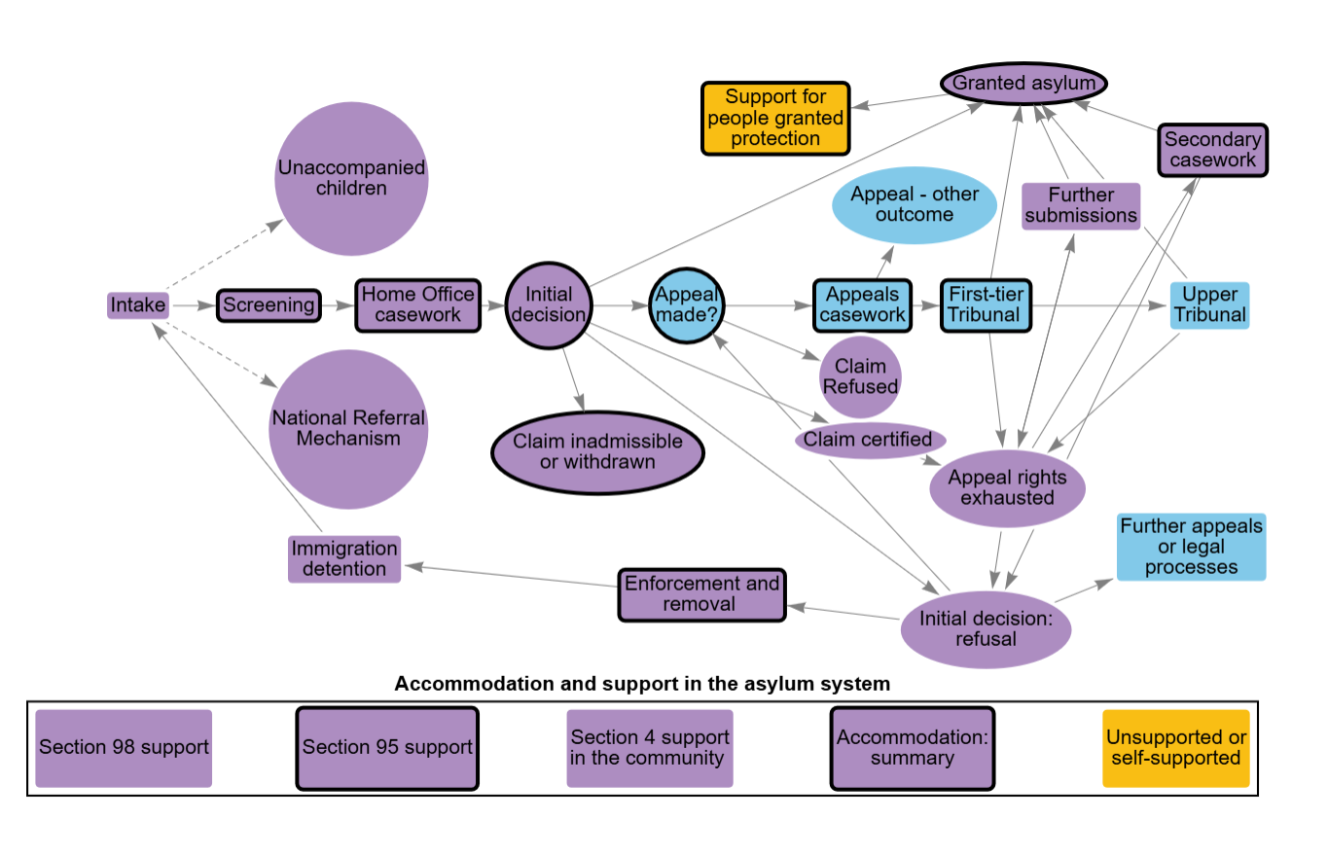

Accompanying text for a whole-system approach
Our work over many years auditing government’s operational delivery of services has shown that taking a whole-system approach is one of the most important foundations for success.
In a whole-system approach, organisations across the system work collaboratively to establish a shared understanding of objectives and service outcomes. When it is done well there is a focus on overall effectiveness and outcomes, rather than what is good for one part of the system.
There is no single point of accountability for outcomes or governance structure for the end-to-end asylum system.
The parts of government involved in asylum each have their own wider objectives, distinct legal duties, statutory responsibilities and budgets.
However, the lack of a whole system approach means that the government has not set out the overall outcomes it aims to achieve through the asylum system, or agreed shared objectives across the different bodies involved.
The system has had to adapt over time to changing volumes of demand and changing government policies on asylum. But interventions to improve the management of demand have tended to be reactive and focused on fixing an urgent problem in one part of the system only, such as intake or initial decisions, without a clear view of the effects on other parts.
Efficiency in each part of the asylum system depends on casework and data about people flowing smoothly from the previous stage. But a siloed structure means there are weak incentives for officials in one part of the system to actively support efficiency in other parts, which can lead to rework, delays, and costs.
The use of feedback across the whole system for understanding and improvement has been limited and inconsistent.
Creating a truly effective whole system approach will require system leadership, political support and collaborative decision making by the bodies involved. They will need a willingness to test, understand and learn from the impacts of the proposed policy changes on the whole system. The government has in train, or has announced, some relevant actions and improvements. For example:
The Home Office has established a new Asylum Group (previously called the Asylum Taskforce) to work with other departments and the centre of government.
The Home Office is building its capability in system design, process modelling and evaluation to understand case flow and policy impacts.
The Home Office and HMCTS are working to improve information sharing and collaboration, including projections and assumptions for better planning.
Since 2019, the Home Office has introduced quality review stages to test how well-founded its decisions are before going to appeal.

Figure detail for whole systems approach

Granted asylum
Efforts in 2023 to clear the backlog of initial asylum decisions also led to a notable increase in individuals who had been granted protection status presenting to local authorities as homeless and requiring support, heightened by the requirement to leave Home Office-provided accommodation within 28 days.

Secondary casework
Home Office teams handling secondary caseworking told us there is no formalised way to go back to teams making the initial decisions with feedback. Delays can also be caused by individuals making appeals or their legal representatives not complying with the tribunal's requirements, for example by not providing documentation in a timely manner.

Screening
The Home Office is responsible for ensuring the UK complies with its legal commitments to people seeking asylum. It manages the intake of people seeking asylum, makes decisions on claims, and manages the enforcement of the Immigration Rules, including removing people who have no right to remain in the UK. The Home Office has a statutory duty to accommodate and support people seeking asylum who would otherwise be destitute while their claim is being considered.
In its 2024-25 Annual Report and Accounts, the Home Office set a priority outcome of "increasing control and fairness in the Migration and Borders System to strengthen border security." This included aims to improve asylum decision making; reduce the overall asylum accommodated population and use better value accommodation to end the use of hotels; and remove those with no right to be in the UK.

Home Office casework
Home Office case progression teams receive some cases that are not ready for review, often because of insufficient or missing evidence from earlier stages. This requires additional documentation or a second interview, introducing delays.

Initial decision
The government’s commitment in December 2022 to clear the legacy backlog (claims made before the Nationality and Borders Act came into force) by December 2023 led to faster initial asylum decisions. In 2023, the Home Office made more than four times as many initial asylum decisions as in 2022, mainly in the second half of 2023, which saw nearly 76,000 initial asylum decisions made. However, this shifted pressure into the appeals stage where constraints on legal and judicial capacity created another backlog.

Appeal made?
The Ministry of Justice (MoJ) and HM Courts & Tribunals Service (HMCTS) administer appeals and tribunals, working with the independent judiciary. The MoJ is also responsible for the provision of legal aid, which is administered through the Legal Aid Agency.

Appeals casework
Delays in the Home Office providing information to the tribunals to support appeals or late notice withdrawals by the Home Office can lead to inefficient use of tribunal capacity and disrupt case scheduling.
Delays can also be caused by individuals making appeals or their legal representatives not complying with the tribunal's requirements, for example by not providing documentation in a timely manner.

First-tier Tribunal
There is no systematic or formalised mechanism for learning from upheld appeals to improve the quality of the initial Home Office decision. However, Home Office teams do carry out ad-hoc reviews to look for patterns in appeal outcomes and learning for staff, and caseworkers are encouraged to attend tribunals. The Home Office is in the process of implementing a five-step quality improvement plan for asylum decision-making. This includes plans for targeted coaching for decision-makers, error-based interventions to address common mistakes, and more centralised appeals analysis and feedback loops to improve decision-making.

Claim inadmissible or withdrawn
The Illegal Migration Act 2023 (IMA) introduced a new duty to remove people arriving or entering the UK illegally and added a provision that declared asylum claims made by those people were inadmissible, and that they could not be granted permission to remain in the UK. The then government put this into practice in July 2023 but, because its Rwanda scheme for removals was not live and it could not remove those people, the effect was to pause asylum decision-making in respect of individuals who had arrived in the UK illegally since 7 March 2023. Decision-making resumed for this cohort in July 2024, when the government passed regulations that removed the retrospective effect of the IMA. This created an additional backlog in initial asylum decisions, as the Home Office was now required to make a decision in the paused cases.

Enforcement and removal
Increased decision volumes as part of efforts to clear the backlog of asylum claims in 2023 were also expected to lead to increased pressure in Immigration Enforcement, including detention, escorting and returns operations.

Accommodation: summary
Inconsistent engagement between the Home Office, asylum accommodation providers and local authorities can lead to competition for the same accommodation resources or tension over accommodation choices. Strategic Migration Partnerships (SMPs) told us that the Home Office have not made the best use of their relationships with SMPs to facilitate better engagement with local authorities.
Our 2024 investigation into the Home Office’s plans to establish large sites to accommodate people seeking asylum and reduce the use of hotels found that the Home Office had faced legal challenges regarding its obligations on the grounds of planning regulations and the impact on local people.

Section 95 support
Plans to close asylum hotels and expand alternative accommodation options may move pressure and costs onto local authorities.

Support for people granted protection
Local authorities have a statutory duty to assist people who are homeless or at risk of being homeless, including those who have been granted asylum. They also have a duty to safeguard people seeking asylum who live in their area. They are supported by Strategic Migration Partnerships (SMPs) which provide leadership and coordination on migration in each region and can assist with strategic leadership, consultation and project management, as well as engagement with the Home Office.
The Ministry of Housing, Communities and Local Government (MHCLG) delivers local authority funding and supports homelessness prevention and relief, including for people granted asylum who leave asylum accommodation.

Addressing fundamental barriers
To deliver value for money, the asylum system needs to be able to process and decide claims in a fair efficient and timely way and implement those decisions, including enforcing removals. Lengthy delays put at risk the welfare and life chances of people seeking asylum, represent an unproductive use of taxpayers’ money on accommodation and support, and erode public confidence in the system’s fairness and effectiveness.
There are opportunities to enhance the efficiency and quality of the current system for processing asylum claims. However, without removing some of the fundamental barriers to progressing claims, or designing the system to take account of them, some people seeking asylum will continue to remain in the system for extended periods. This prevents the system from operating as it should, and undermines the government’s ability to achieve value-for-money. Those without valid claims may also exploit these aspects of the system to stay in the UK when they are not genuinely in need of asylum.
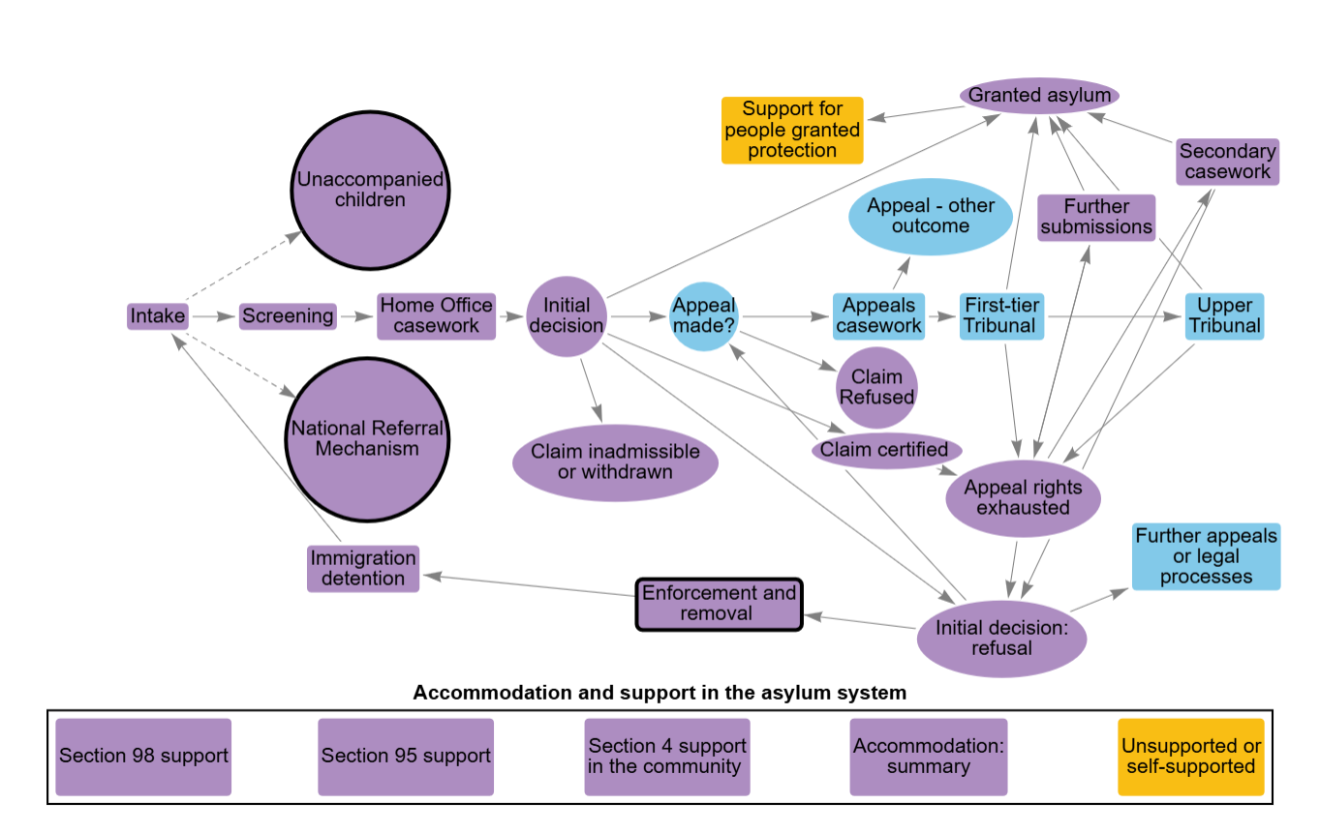

Accompanying text for addressing fundamental barriers
To deliver value for money, the asylum system needs to be able to process and decide claims in a fair efficient and timely way and implement those decisions, including enforcing removals. Lengthy delays put at risk the welfare and life chances of people seeking asylum, represent an unproductive use of taxpayers’ money on accommodation and support, and erode public confidence in the system’s fairness and effectiveness.
There are opportunities to enhance the efficiency and quality of the current system for processing asylum claims. However, without removing some of the fundamental barriers to progressing claims, or designing the system to take account of them, some people seeking asylum will continue to remain in the system for extended periods. This prevents the system from operating as it should, and undermines the government’s ability to achieve value-for-money. Those without valid claims may also exploit these aspects of the system to stay in the UK when they are not genuinely in need of asylum.
A key factor that stops the system from operating as intended is the inability to promptly return some people who have exhausted their appeal rights but do not leave voluntarily. Where detention is used for the purpose of removal, legislation requires that the Home Office should only use it when there is a realistic prospect of removal within a 'reasonable' period of time. Where this is not possible, some individuals remain within the asylum system, with their cases unresolved. This leads to significant expenditure on support and accommodation or detention, without progress towards resolution of the case.
Another feature of the current system is the potential for repeated claims and appeals processes.
UK law protects the right to appeal an asylum decision through a statutory process involving an independent tribunal. In addition, there is no limit on the number of times an individual may make further submissions to the Home Office with new evidence that might change the outcome of their claim, even late in the process or after appeal rights against the initial claim are exhausted. Further submissions provide a further right of appeal, even if an individual’s appeal rights had previously been exhausted.
The right to appeal a decision that an applicant or their legal representative feels is incorrect, and the ability to provide new information to Home Office decision-makers, are important in ensuring fairness in the asylum system. Moreover, there are several legitimate reasons why repeated submissions and appeals might occur. They may reflect genuinely new information or valid changes in an individual's circumstances, or may be due to the complexity of the system and the difficulty applicants face in engaging with it. In some cases, however, they can be a deliberate act by people with no legitimate right to asylum to frustrate their removal.
Frequent changes in policy on asylum have been a feature of recent years. Global instability also means that the government’s guidance on which countries are deemed safe can change. Both types of change alter asylum claim admissibility rules and may overturn an initial decision by the time it reaches tribunal. If policy or country changes affect a whole group of claimants, this creates a surge in work on appeals and/or returns which may need additional staff and resources.
All of these system features can prolong the time that claimants spend in the asylum system. There is also a reinforcement effect between these features and process inefficiencies. Process delays make it more likely that the individual is deemed to have established a life in the UK or that the circumstances in their home country have changed, which may change the ultimate outcome on their claim. Data limitations means that it is not possible to see how many cases involving an asylum claim were eventually granted on the grounds of Article 8 of the Human Rights Act (1998), which protects an individual's right to private and family life.
In all cases, long delays waiting in the asylum system create uncertainty and hardship for claimants, extend the time in which they are unable to work and participate in society, and make integration for people granted asylum harder.
The government has recently announced some significant new measures on increasing removals and addressing other system barriers. Already under way are:
The UK-France returns treaty and pilot "one in, one out" scheme. The pilot aims to demonstrate whether a new bilateral approach to returning people arriving by small boats whose asylum claims have been declared inadmissible to the UK system will work in practice.
New or updated returns arrangements announced with Iraq, Moldova, and a joint communiqué with Vietnam.
The UK, alongside its Five Eyes partners, has committed to adjusting visa access for countries that refuse or delay accepting the return of their nationals.
Increasing use of AI facial age recognition technology with the aim of strengthening age assessment.
Newly proposed measures yet to be implemented, some of which will require Parliamentary approval, include:
Measures to enforce removals to countries which are judged to be safe, and to remove families with failed claims if their home country is judged to be safe.
Introducing a faster track for appeals assessed as having low prospects of success, moving to a single right of appeal for each claim, and tightening the rules on further submissions so that only evidence that is materially different from that considered in the original decision can be raised.
Legislation to reform the interpretation of human rights and modern slavery protections and prevent their misuse by people not entitled to protection.
Measures that seek to increase contributions by people seeking asylum to the cost of their support, where they have assets or income. The government has not announced changes to the list of permitted occupations for people seeking asylum awaiting a decision.

Figure detail for addressing fundamental barriers

Enforcement and removal
- The UK has limited bilateral agreements with some countries on returns. This applies to some countries from which asylum claims are normally certified as ‘clearly unfounded’. Even where agreements exist, compliance by foreign authorities can be limited.
- Individuals can be returned to countries with whom the UK does not have a formal returns agreement - these are facilitated through operational engagement and agreement. In some cases, countries do not or cannot provide adequate co-operation on returns due to wider political issues.
- Some individuals do not have verifiable identity documents and cannot obtain them from their country of origin. This can cause significant delay in arranging returns.
- Complex appeals processes delay removal, and fresh evidence submissions or human rights claims often arise late in the process, requiring reconsideration and halting removal action.

National Referral Mechanism
Case progression can also be impacted by other factors. These include genuine changes in circumstances – such as a referral to the National Referral Mechanism for potential victims of modern slavery – or by claimant behaviour, such as non-compliance from claimants (for example, failure to attend interviews).

Unaccompanied children
Case progression can also be impacted by other factors. These include genuine changes in circumstances – such as a referral to the National Referral Mechanism for potential victims of modern slavery – or by claimant behaviour, such as non-compliance from claimants (for example, failure to attend interviews).

Timely, robust, shared data
We frequently find across government that robust data are not a priority and that there is a culture of tolerating and working around data that are not fit for purpose. It can be challenging to make the case for long-term investments to improve the quality and sharing of data. And government tends to be poor at monitoring the time and costs involved in sorting poor-quality, disorganised data, which exacerbates that challenge. Our work on complex cross-government systems also shows how important it is for leaders to have an understanding, based on a shared set of trusted data, of what is happening across the whole system and why.
Poor quality data and workarounds have been a long-standing characteristic of the asylum system. While there have been positive improvement in some areas, data availability, quality, and interoperability continue to create challenges managing the end-to-end asylum system effectively.
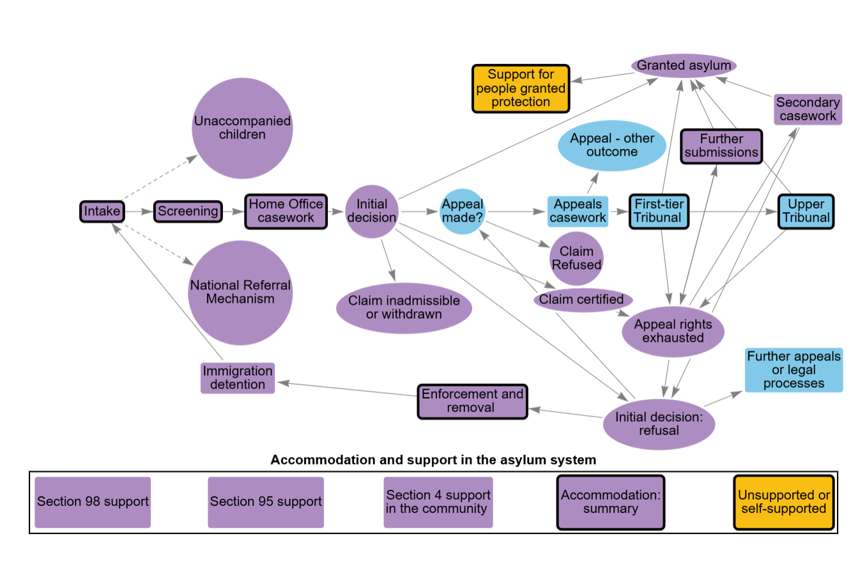

Accompanying text for timely, robust, shared data
We frequently find across government that robust data are not a priority and that there is a culture of tolerating and working around data that are not fit for purpose. It can be challenging to make the case for long-term investments to improve the quality and sharing of data. And government tends to be poor at monitoring the time and costs involved in sorting poor-quality, disorganised data, which exacerbates that challenge. Our work on complex cross-government systems also shows how important it is for leaders to have an understanding, based on a shared set of trusted data, of what is happening across the whole system and why.
Poor quality data and workarounds have been a long-standing characteristic of the asylum system. While there has been positive improvement in some areas, data availability, quality, and interoperability continue to create challenges managing the end-to-end asylum system effectively.
In 2023, we reported that the Home Office had been slow to implement its new case management system, Atlas. At the time, asylum caseworkers were using two systems to enter or update the same information. The Home Office has now moved fully to Atlas for asylum case management (as well as all other migration and borders casework), but the transition has been complex and there is further to go on data quality, system functionality and data sharing with other parts of government.
The Home Office has faced significant challenges with transferring and merging its legacy data, improving functionality and upskilling staff to create a single reliable record in Atlas for each person seeking asylum. The process of resolving identities and linking records across systems is ongoing. The lack of a single, complete, reliable record of all the necessary data on each person seeking asylum is a constraint on the efficiency and quality of decision-making and the Home Office’s ability to manage and forecast demand across the system.
There are barriers to effective information sharing between different bodies across the asylum system. There is no unique asylum case identifier shared by Home Office, HMCTS and local authority systems. The Home Office and HMCTS have developed arrangements to exchange data directly between their Atlas and the new HMCTS appeals case management system (CCD). However, we saw problems with data sharing across the system making it impossible to directly track individual cases through the entire asylum process.
We recommended in previous audit work that the Home Office routinely collect the data necessary to understand the flow of demand through the whole asylum system, and the impact of policy changes on people seeking asylum. In this audit, we found several examples of data that could help the government better understand outcomes within the asylum system that were not routinely being collected, or which they could not provide.
The Home Office told us it has assessed the maturity of its data on asylum and is using the results to develop a data strategy which reflects the Government Data Quality Framework. It has a programme of work planned that will focus on improving data input quality, building staff’s trust in Atlas, and establishing robust data controls. At the same time, the Home Office is continuing to make engineering improvements to the underlying architecture of Atlas.
The Home Office also told us it is working to improve data flows to other parts of the system. At various stages of development, it has introduced: a Place-Based Visibility Tool, which provides local authorities with data to support accommodation planning and service delivery; a tool to extract data to transfer to HMCTS; a process for sharing information when asylum-seeking children move schools which is being finalised with the Department for Education; and a Property Management Platform to provide data on people seeking asylum in supported accommodation.

Figure detail for timely, robust, shared data

Intake
Errors or omissions in the data recorded in Atlas about people at the point they make their asylum claim was leading to time-consuming follow-up later by decision-making staff.

Screening
While the aspiration is to track individuals from arrival through to accommodation and casework, in practice, the system can only provide a general overview. There are gaps in the ability to break down time spent at different stages or to follow individual journeys without manual effort, especially where data is missing or not joined up.

Home Office casework
Staff were continuing to refer back to the closed CID system that Atlas has replaced and there was evidence of case identifying numbers from that system still being used.
Some teams used additional spreadsheets to help them manage their flow of work because Atlas does not yet provide the functionality they need.

First-tier Tribunal
The MoJ did not hold reliable data on the level of repeated appeals.

Upper Tribunal
The MoJ could not provide data on the total number of cases received by the Upper Tribunal, although it told us they have a manual system in place for the Upper Tribunal to collate and share management information on a four-week retrospective basis.

Enforcement and removal
The Home Office did not hold complete data on the number of people who had absconded from the asylum system, or the total number of people currently subject to some form of enforcement action, or on all unsuccessful removals and their causes.

Accommodation: summary
Information sharing between the Home Office, local authorities, accommodation providers, and other relevant parties such as the police about safeguarding and risk management is not aways effective. Local authorities have a statutory duty to safeguard adults seeking asylum living in their areas. However, both the Home Office and representatives of local authorities told us that it was difficult to share information consistently and effectively. This is made more complicated by the fact that there is no standardised process for sharing information - including about safeguarding and other needs - with and between local authorities and other local services.

Unsupported or self-supported
The Home Office was unable to provide data on the number of people in the asylum system who were not receiving any form of state support or state-funded accommodation.

Support for people granted protection
A lack of standardised information flow between local authorities and from the Home Office and accommodation providers to local authorities means that councils are not always notified when people move into or out of their areas, and may not be notified promptly when people who have been granted asylum move out of asylum accommodation. This hampers the ability of local authorities to provide appropriate, proactive support or to plan and allocate resources effectively.

Further submissions
The Home Office could not provide data on the outcomes of further submissions.

A resilient, strategic approach to capacity and workforce
In efficient systems that deliver sustainable value for money, work is done right first time; work moves through the process at the pace needed to meet service users’ needs without creating backlogs; and hand-offs between different people and steps in the process are seamless. The asylum system is subject to fluctuating demand and significant peaks driven by external factors. It is therefore even more important to understand how cases flow through the whole system, address capacity constraints and design in flexibility to demand, while designing out the causes of failure, inefficiency and rework.
There are several clear capacity constraints which limit the effective functioning of the asylum system, and addressing them is very challenging, particularly in the context of fiscal restraint, housing shortages and limits on civil service recruitment. Each of the systems within the asylum system is under pressure more widely, not just on managing asylum.

Accompanying text for a resilient, strategic approach to capacity and workforce
In efficient systems that deliver sustainable value for money, work is done right first time; work moves through the process at the pace needed to meet service users’ needs without creating backlogs; and hand-offs between different people and steps in the process are seamless. The asylum system is subject to fluctuating demand and significant peaks driven by external factors. It is therefore even more important to understand how cases flow through the whole system, address capacity constraints and design in flexibility to demand, while designing out the causes of failure, inefficiency and rework.
There are several clear capacity constraints which limit the effective functioning of the asylum system, and addressing them is very challenging, particularly in the context of fiscal restraint, housing shortages and limits on civil service recruitment. Each of the systems within the asylum system is under pressure more widely, not just on managing asylum.
Availability of judges is the biggest constraint on increasing sitting days in the appeals system.
Individuals seeking asylum are eligible for legal aid, subject to a means and merits test. This includes advice on their initial application to the Home Office and advice and representation at an appeal.
There are acute challenges with the supply of legal aid services.
The lack of legal advice and representation can mean that issues which could have been resolved at the initial decision stage are instead pushed to appeal, increasing the appeals backlog.
The MoJ also told us that there has been an increase in the number of claimants representing themselves in person at tribunal who do not have the skills to represent themselves effectively. This requires additional support from legal officers, and can result in further disruption and delay for the tribunal.
Home Office caseworkers in asylum case management have a challenging role. They face complex cases and changing guidance. The robustness of asylum decisions depends on their skills, training, and the support provided to them.
A shortage of dispersal accommodation has led to the Home Office using hotels and large sites as contingency accommodation.
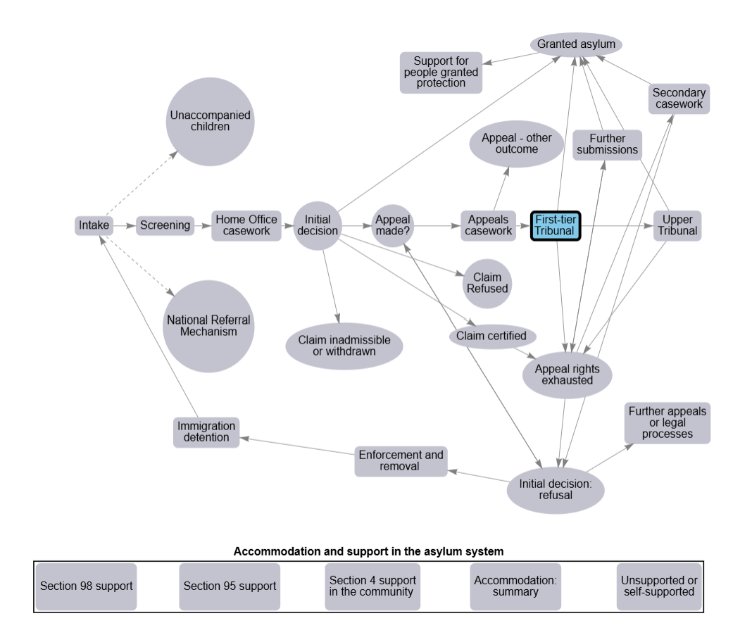

Figure detail for a resilient, strategic approach to capacity and workforce

Home Office casework
Staff retention is improving but rates of churn are still high. Managers felt it took on average seven months for new staff to become fully effective in their roles, and yet in 2024-25 there was an almost 35% staff attrition rate for asylum caseworkers in the Home Office, although this was reducing in the first half of 2025-26. Decision-makers learn valuable skills in their role and this makes them marketable elsewhere.
Quality assurance checks reveal continued quality issues, with 42% of sampled decisions in a rolling twelve months to May 2025 having significant or fail errors.
The Home Office has returned to more rigorous recruitment procedures for decision-makers, and implemented a quality improvement plan. It is focused on improving technical support to caseworkers, addressing their knowledge gaps through targeted coaching, and bringing together feedback from appeals to improve decision quality. The Home Office is also trialling the use of artificial intelligence tools to summarise lengthy case notes to save time for decision-makers.
Government announced in November 2025 a proposed change in the length of time for which successful people seeking asylum are granted leave to remain, from five years to 30 months. It will be renewed only if the individual is still considered in need of protection. The implications of these more frequent reviews of right to remain on the Home Office's case management capacity or on the appeals system is not yet clear.

Appeal made?
The Ministry of Justice's (MoJ) review of civil legal aid showed that the immigration and asylum sector faces acute challenges with high demand and a shortage of legal aid providers in some areas, largely driven by unsustainable fee levels. There are particular pressures in some areas such as south-west England.
MoJ is taking action to support the capacity of the market, including fee uplifts to improve the financial viability of asylum and immigration civil legal aid work and incentivise providers to take up and expand their legal aid work.
The government has indicated that the planned new independent appeals body will also provide people seeking asylum with independent legal advice.

First-tier Tribunal
We heard that cases were sometimes listed but had to be adjourned at short notice due to no judge being available.
The Ministry of Justice (MoJ) finds it challenging to recruit enough salaried judges across its tribunals, including for the Immigration and Asylum Chamber (IAC) of the First-tier Tribunal, particularly when compared with fee-paid roles. Recent recruitment campaigns have fallen short of targets. Judges told us there were poor incentives for working in the IAC in comparison to other competing tribunals, due to the complex and taxing nature of asylum appeals work which make up an increasing proportion of cases heard by the IAC. Frequent policy changes have also created an additional training burden.
Judges also pointed to negative media attention and personal attacks on judges in the press as factors making recruitment more challenging.
MoJ is considering a range of ways to improve judicial capacity as well as recruitment, including authorising judges from other First-tier Tribunal chambers to sit in asylum cases. In September 2025, the government announced the creation of a new independent appeals body with statutory powers to prioritise cases from those in asylum accommodation and Foreign National Offenders.
To help address capacity constraints, the Ministry of Justice uses the legal officer role to support judges and make better use of their time. Legal officers assist with case management and preparation, helping cases reach hearings efficiently and ensuring court time is used effectively. This support also helps reduce the number of adjournments caused by poor evidence quality, saving judicial time.

Section 95 support
The Home Office has few levers to control the cost of hotels which may be more profitable for the suppliers than other forms of accommodation. It began using vessels and ex‑military bases (large sites) in 2020 as an alternative to hotels and continues to work with the Ministry of Defence on potential new sites for asylum accommodation.

Study team
The National Audit Office study team consisted of: Gigs Banga, Lana Eekelschot, Ciaran Fitzsimons, Antonia Gracie, Hannah Kreczak, Sue Leveson and Rebecca Mavin under the direction of Ruth Kelly.

